CMA’s XBRL Based Electronic Filing Platform

IFSAH

Case Study for Firms practicing securities activities (including brokerages)
Version 1.0

Contents
1. Creating a filing 3
2. Filing information 4
3. Statement of financial position 4
4. Income Statement 12
5. Statement of Comprehensive Income 16
6. Statement of Cash Flows 19
7. Statement of Changes in Equity 23
8. Notes to Financial Statements 26
9. Fair Value through Profit and Loss Investments 29
10. Financial Assets at Fair Value through Other Comprehensive Income 31
11. Financial Assets Carried at Amortized Cost 32
12. Investments in Associates 32
13. Borrowed Funds 33
14. Asset Management Portfolio 34

Creating a filing

On opening the iFile Tool, the filer can click on the ‘Click here to Create Filing’ button.
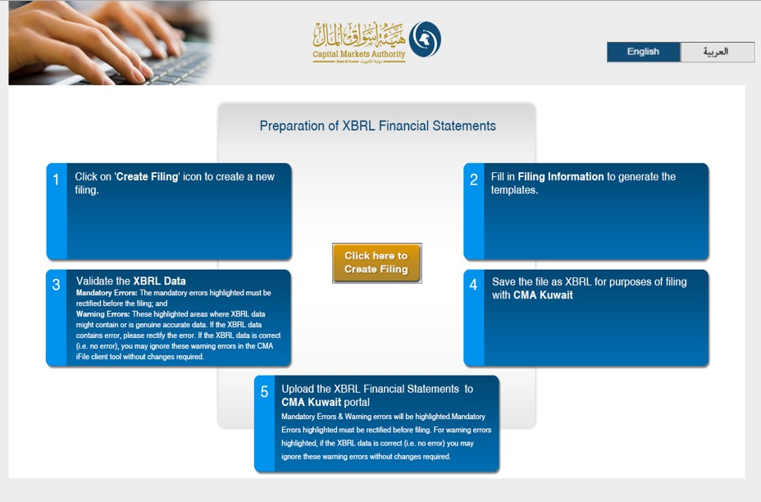

Filing information

By clicking on the ‘Click here to Create Filing’ button, the user will be redirected to the CMA iFile pop-up, where he/she will be required to input information about the reporting entity.

Statement of financial position

Following is a snapshot of the company’s Statement of Final Position, from their annual report.
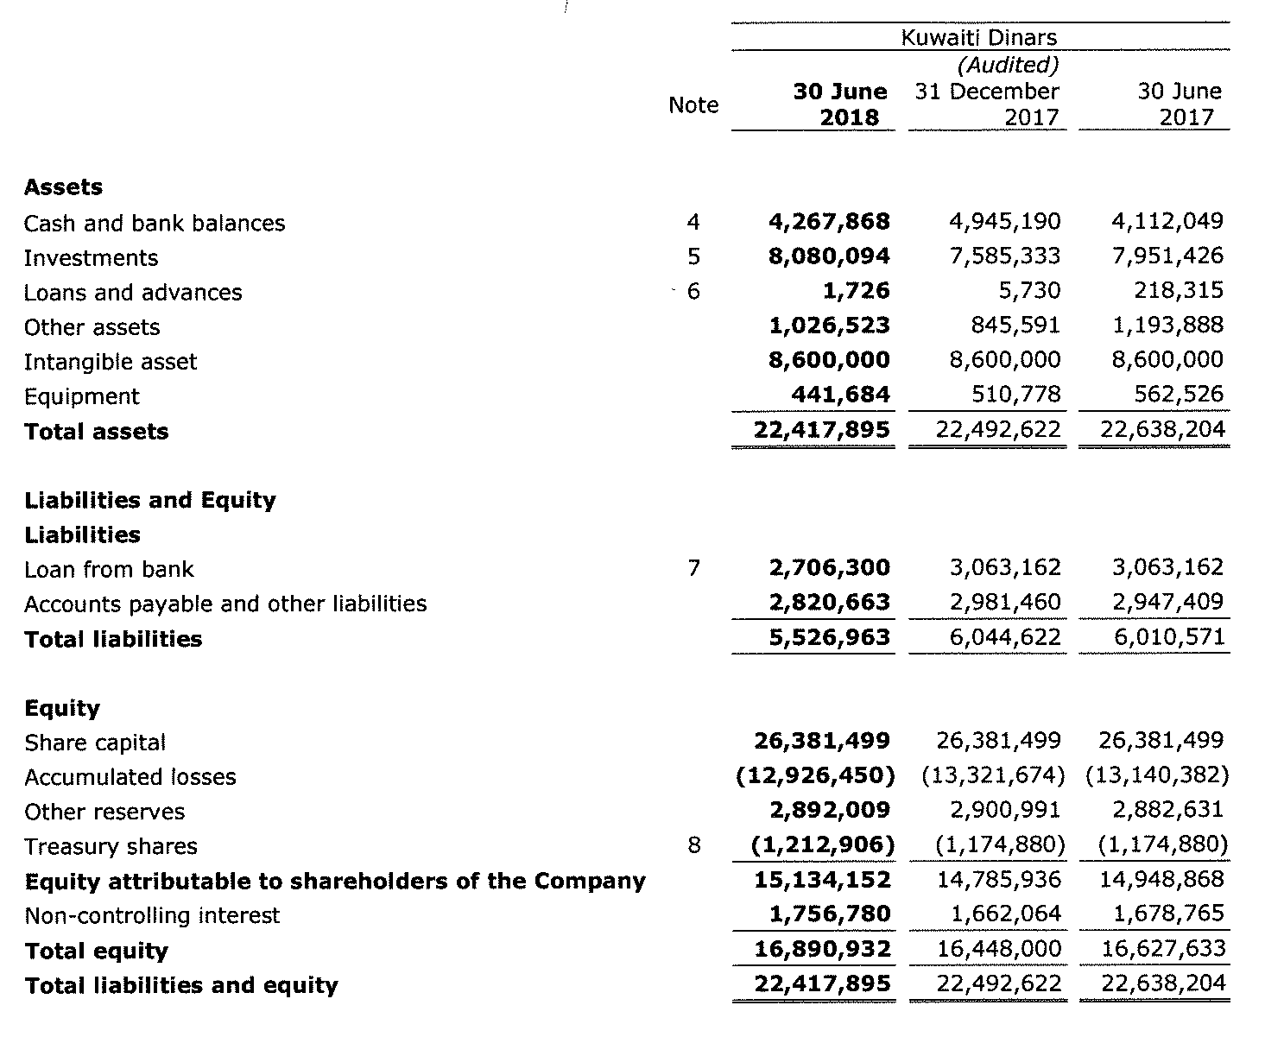

The iFile tool contains two statements for the Statement of Financial Position:
- Statement of financial position “the main statement”
- Sub-classifications of assets, liabilities and equity “the sub-classifications statement”
Some of the concepts in the main statement will be linked to the subclassification statement. For example, ‘Cash and Cash Equivalents’ in the main statement is linked to the sub-classification concepts in the sub-classifications statement. Following is the extract of the subclassification of ‘Cash and Cash Equivalents’ and ‘Term deposits’ as filled in iFile based on the data available in report extract shown below: 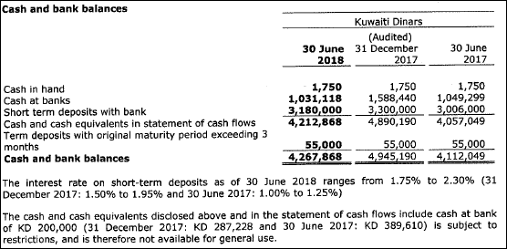

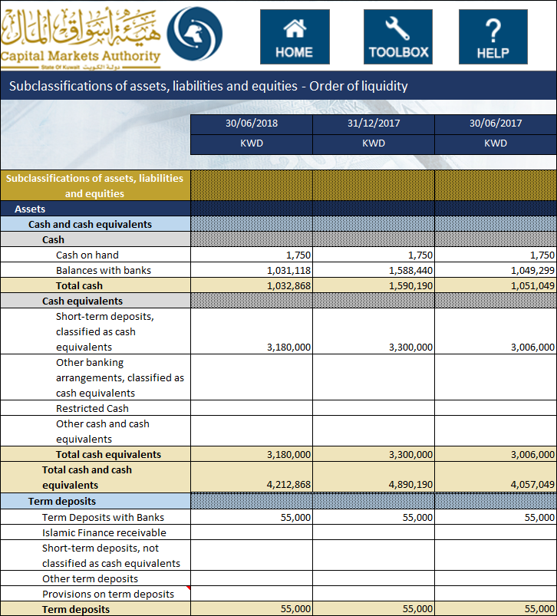

Additionally, ‘Loans and advances’ are mapped to ‘Credit facilities’. The total will be reflected as shown in the report and will be shown in the main statement of iFile as shown below:
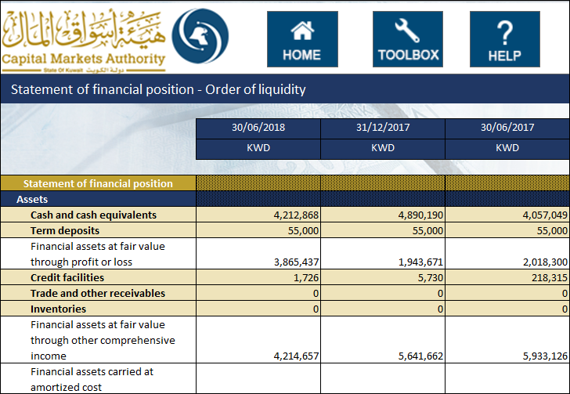
The company also reports accumulated losses in the Statement of financial position. As the financial concept used in iFile ‘Retained earnings (Accumulated losses)’ has a credit balance, the value of accumulated losses is entered in negative (and displayed in red color). Whereas, the financial concept for ‘Treasury shares’ used in iFile has a debit balance, representing a negative impact on total equity (which has Credit balance). Hence, even though value of treasury shares is shown as negative in the report (as shown in the extract of report above), it is entered as a positive amount in iFile. This is shown as follows:

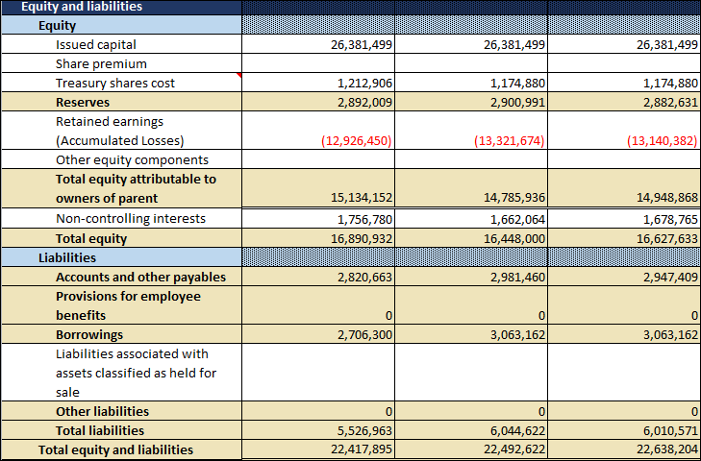
Some of the concepts in the main statement will be linked to the sub classification statement.
The Values in the concepts highlighted in light brown are automatically updated in the main statement when the value is entered in the sub classification statement, except the Totals. By the side of the concepts, linking have been done as ‘Go to the relevant concepts’. When the user clicks at ‘Go to the relevant concepts’ the user is directed to the statement from where the values has been derived and vice-versa.
List is as follows:-
- Cash and cash equivalents
- Term deposits
- Term deposits, current
- Trade and other receivables
- Term deposits, non-current
- Credit facilities
- Inventories
- Investment in associates
- Investment in joint ventures
- Investment Properties
- Intangible assets
- Property, plant and equipment
- Other assets
- Reserves
- Accounts and other payables
- Provision for employee benefits
- Other liabilties

Addition to above, some concepts are linked to the non-standard statements those are as follows:
- Financial assets at fair value through profit or loss
- Financial assets at fair value through other comprehensive income, current
- Financial assets carried at amortized cost, current
- Financial assets at fair value through other comprehensive income, non-current
- Financial assets carried at amortized cost, non-current
- Investment in associates
- Investment in joint ventures
- Investment in subsidiaries
- Financial assets at fair value through other comprehensive income
- Financial assets carried at amortized cost
- Goodwill
- Borrowings
- Borrowings, non-current
- Other liabilities

Following is the list of business concepts for which mandatory inputs are required. In the event that the company does not have any inputs, the user can input ‘0’, and the same will be displayed in the final filing document.
- Total assets
- Total equity
- Total liabilities
- Cash and cash equivalents
- Issued capital
- Retained earnings
Additionally, for the following concepts, when the user enters a positive value in the CMA iFile, that value will be deducted from the total, and vice-versa. For example, if the user enters positive value for ‘Treasury shares cost’, the value will be deducted from the total concept ‘Total equity’, and vice versa.
Following is the list of elements that have a negative effect on the total:
- Treasury shares cost
- Total Provisions
- Provisions on trade and other receivables

Income Statement

Following is the Statement of Income from the Report:
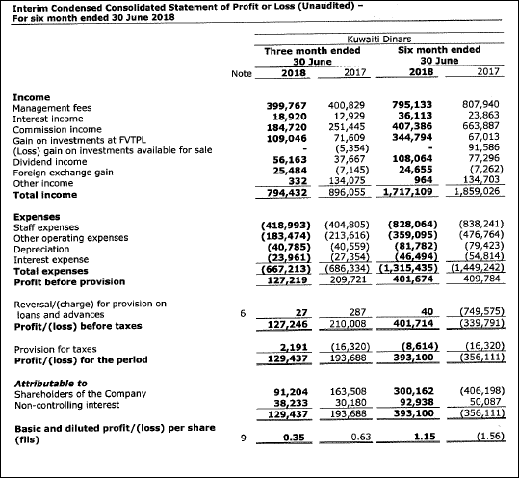
The iFile tool contains two statements for the Consolidated Statement of Income:
- Income statement “main statement”
- Analysis of income and expenses “analysis statement”
After entering all values, the Income statement is shown in iFile will display the following:
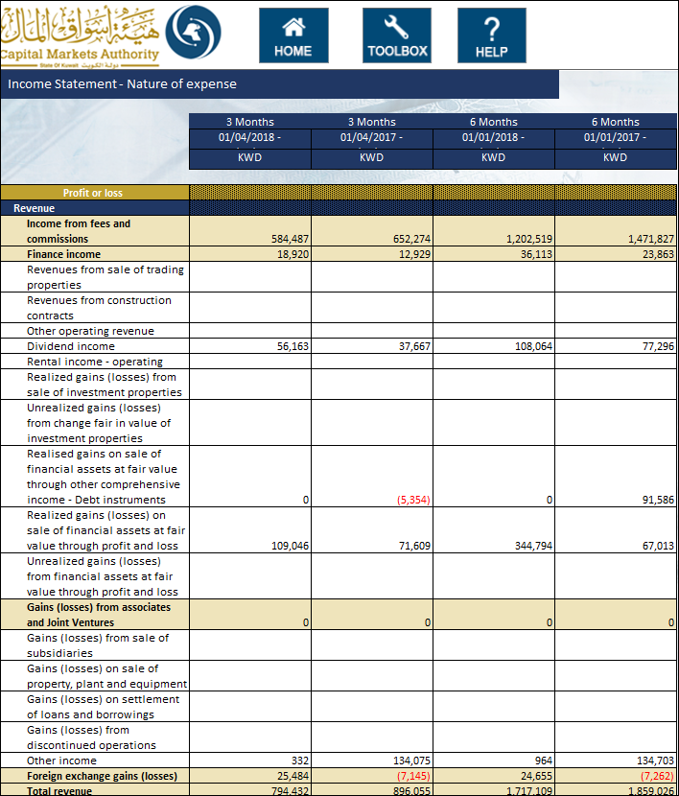
Some of the concepts in the main statement will be linked to the Analysis statement. For example, ‘Income from fees and commissions’ is linked to the Analysis. Following is the extract of the Analysis of ‘Income from fees and commissions’ as filled in iFile based on the data available in report extract shown above
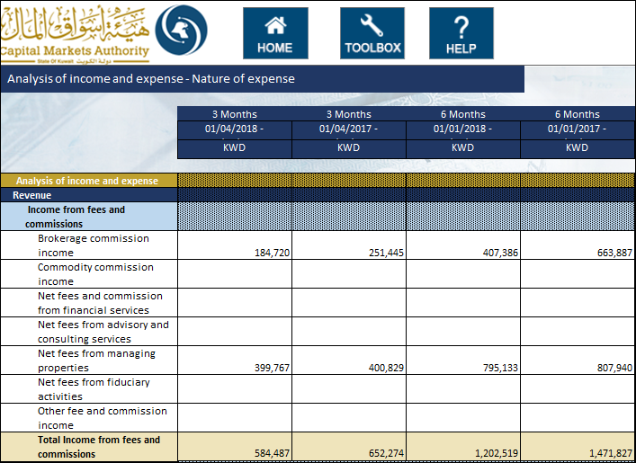
The expenses are added to CMA iFile as follows:
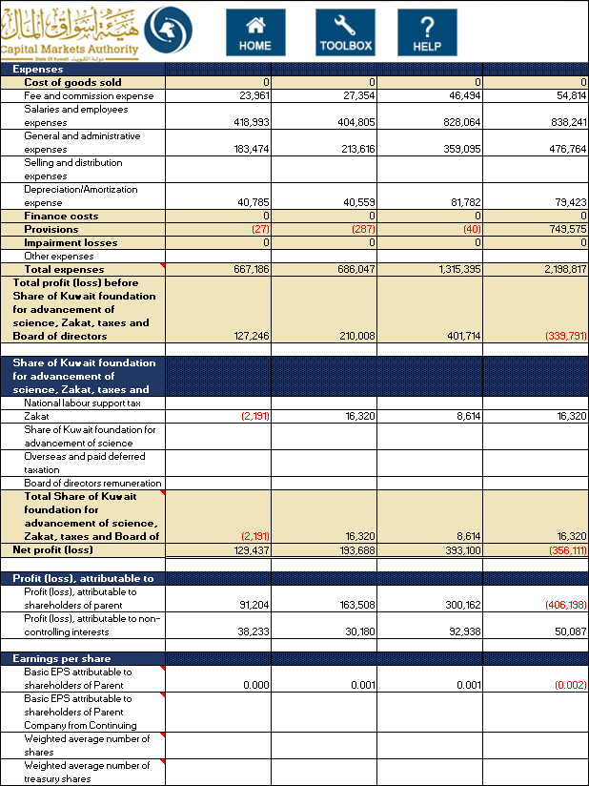
Kindly note that in CMA iFile, the earnings per share are shown in Kuwaiti Dinar (KWD). As the company has reported earnings per share in fils, the same has been converted in KWD and entered in iFile as shown above.
The Values in the concepts highlighted in light brown are automatically updated in the main statement when the value is entered in the Analysis statement, except the totals. By the side of the concepts, linking have been done as ‘Go to the relevant concepts’. When the user clicks at ‘Go to the relevant concepts’ the user is directed to the statement from where the values has been derived and vice-versa.
List is as follows:-
- Income from Fees and Commissions
- Finance income
- Gains (Losses) from associates and Joint ventures
- Foreign exchange gains (losses)
- Costs of goods sold
- Finance costs
- Provisions
- Impairment Losses
Following is the list of business concepts for which mandatory inputs are required. In the event that the company does not have any inputs, the user can input ‘0’, and the same will be displayed in the final filing document.
- Total revenue
- Total expenses
- Net profit (loss)
Following is the list of elements that have a negative effect on the total:
- Total expenses
- Total Share of Kuwait foundation for advancement of science, Zakat, taxes and Board of directors remuneration

Statement of Comprehensive Income

Following is the Statement of Comprehensive Income from the Report:
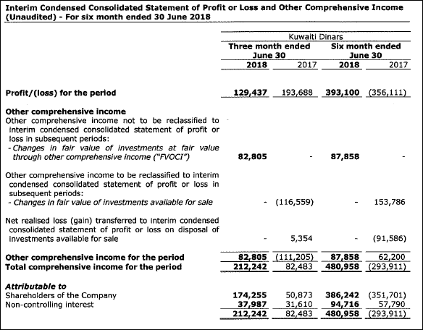
Kindly note the following:
- The concept ‘Net realized loss (gain) transferred to interim condensed consolidated statement of profit or loss on disposal of investments available for sale’, is the same as the following concept in CMA iFile – ‘Reclassification adjustment on Financial assets at fair value through other comprehensive income – Debt instruments due to sale’. This concept have debit balance. As a result, these concepts will have negative impact on other comprehensive income, which has credit balance. Hence, the values entered in iFile are added taking into account the calculation relationship as per the balance type as shown below-
- The concept ‘changes in fair value of investments available for sale’, is the same as the following concept in CMA iFile – ‘Gains (losses)on re-measuring Financial assets at fair value through other comprehensive income – Debt instruments’.
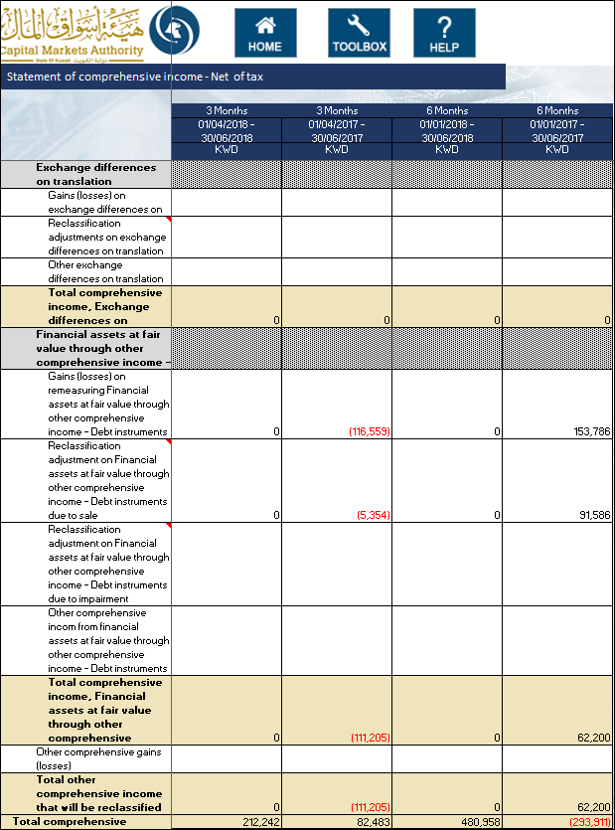
In the event that the company does not have any inputs for ‘Total comprehensive income’, the user can input ‘0’, and the same will be displayed in the final filing document.
Following is the list of elements that have a negative effect on the total:
- Reclassification adjustments on exchange differences on translation
- Reclassification adjustment on Financial assets at fair value through other comprehensive income - Debt instruments due to sale
- Reclassification adjustment on Financial assets at fair value through other comprehensive income - Debt instruments due to impairment

Statement of Cash Flows

Following is the Statement of Cash flow from the Report:
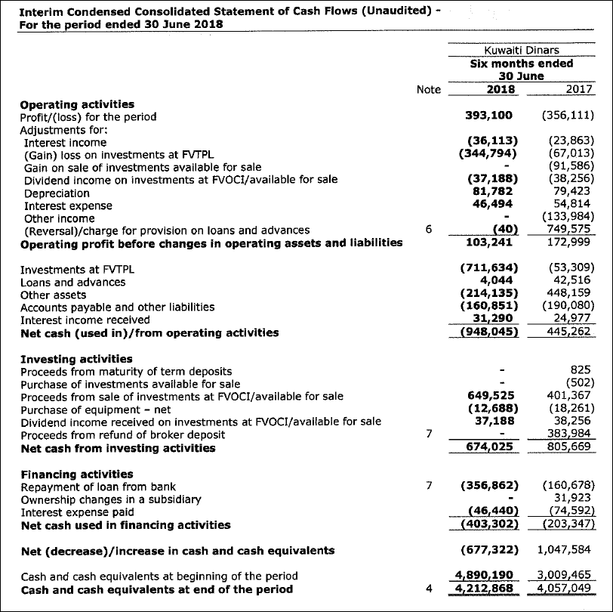
The details in iFile is as follow (an extract of financing activities) -
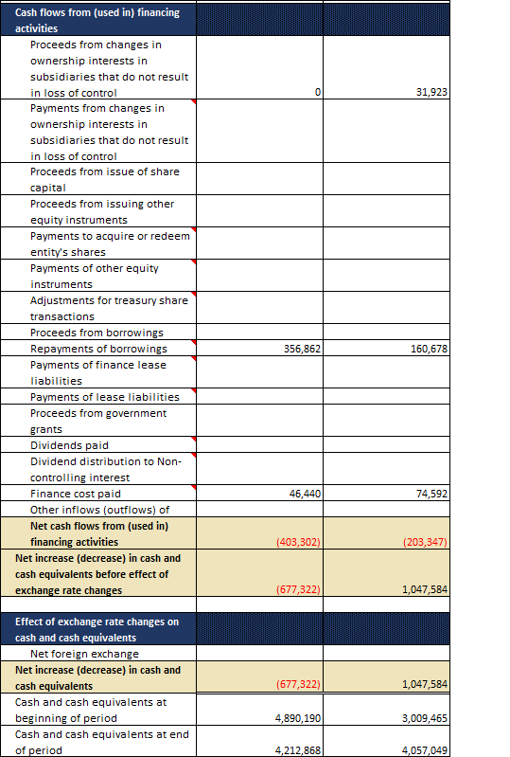
Kindly note the following:
The concept ‘Investments at FVTPL’, is mapped in CMA iFile to ‘Adjustments for decrease (increase) in Trade and other receivables’ and concept ‘ Interest income received is mapped in CMA iFile to ‘Adjustments for increase (decrease) in other operating liabilities’ with a footnote added as shown below:
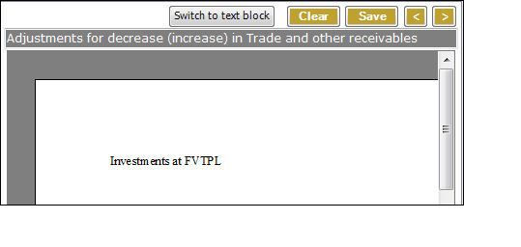
Following is the list of elements that have a negative effect on the total:
- Adjustments for dividend income
- Adjustments for finance income
- Adjustments for Share of results of associates and joint ventures
- Payment for employee end of term benefits
- Cash flows used in obtaining control of subsidiaries or other businesses
- Purchase of interest in Joint Ventures
- Purchase of property, plant and equipment
- Purchase of intangible assets
- Purchase of investment properties
- Purchase of Financial assets at fair value through profit or loss
- Purchase of Financial assets carried at amortized cost
- Acquisition of Investments in associates
- Purchase of financial assets at fair value through other comprehensive income
- Purchase of other long-term assets
- Payments from changes in ownership interests in subsidiaries that do not result in loss of control
- Payments to acquire or redeem entity's shares
- Payments of other equity instruments
- Adjustments for treasury share transactions
- Repayments of borrowings
- Payments of finance lease liabilities
- Payments of lease liabilities
- Dividends paid
- Dividend distribution to Non-controlling interest
- Finance cost paid

Statement of Changes in Equity

Following is the Statement of Changes in Equity from the Report:
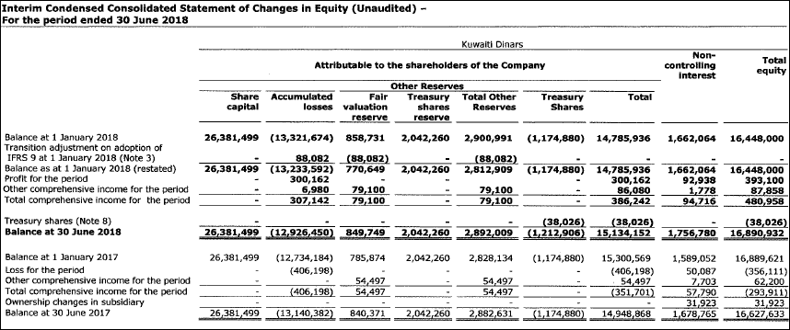
Kindly note the following:
The concept ‘Treasury shares cost’ Column is subtracted from the Total equity calculation; therefore the amounts have been entered in positive as shown below:
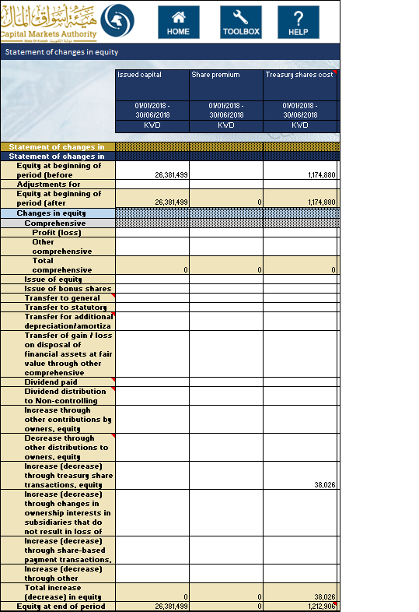
When the value for ‘Preparation format’ in Filing information selected is “Standalone” then Total equity attributable to the parent company and Non-Controlling interest’s column will be disabled.
The information input in this template will have to match that inputted as part of the information inputted in the Balance Sheet.
- The value reported for ‘Issued capital’ in the Statement of changes in equity template must equal the value for ‘Issued capital’ in the Statement of financial position template

- The value reported for ‘Share premium’ in the Statement of changes in equity template must equal the value for ‘Share premium’ in the Statement of financial position template

- The value reported for ‘Treasury shares cost’ in the Statement of changes in equity template must equal the value for ‘Treasury shares cost’ in the Statement of financial position template

- The value reported for ‘Revaluation surplus’ in the Statement of changes in equity template must equal the value for ‘Revaluation surplus’ in the Statement of financial position template

- The value reported for ‘Reserve of exchange differences on translation’ in the Statement of changes in equity template must equal the value for ‘Reserve of exchange differences on translation’ in the Statement of financial position template

- The value reported for ‘Reserve of change in fair value of financial assets at fair value through other comprehensive income’ in the Statement of changes in equity template must equal the value for ‘Reserve of change in fair value of financial assets at fair value through other comprehensive income’ in the Statement of financial position template

- The value reported for ‘Reserve of share in other comprehensive income of associate companies and joint venture’ in the Statement of changes in equity template must equal the value for ‘Reserve of share in other comprehensive income of associate companies and joint venture’ the Statement of financial position template

- The value reported for ‘General reserve’ in the Statement of changes in equity template must equal the value for ‘General reserve’ the Statement of financial position template

- The value reported for ‘Statutory reserve’ in the Statement of changes in equity template must equal the value for ‘Statutory reserve’ the Statement of financial position template

- The value reported for ‘Treasury shares reserve’ in the Statement of changes in equity template must equal the value for ‘Treasury shares reserve’ the Statement of financial position template

- The value reported for ‘Share based payment reserve’ in the Statement of changes in equity template must equal the value for ‘Share based payment reserve’ the Statement of financial position template

- The value reported for ‘Other reserves’ in the Statement of changes in equity template must equal the value for ‘Other reserves’ the Statement of financial position template

- The value reported for ‘Retained earnings (accumulated Losses)’ in the Statement of changes in equity template must equal the value for ‘Retained earnings (accumulated Losses)’ the Statement of financial position template

- The value reported for ‘Other equity components’ in the Statement of changes in equity template must equal the value for ‘Other equity components’ the Statement of financial position template

- The value reported for ‘Equity attributable to owners of parent’ in the Statement of changes in equity template must equal the value for ‘Equity attributable to owners of parent’ the Statement of financial position template (only in case of Consolidated)

- The value reported for ‘Non-controlling interests’ in the Statement of changes in equity template must equal the value for ‘Non-controlling interests’ the Statement of financial position template (only in case of Consolidated)
Following is the list of elements that have a negative effect on the total:
- Transfer to general reserve
- Transfer for additional depreciation/amortization
- Dividend paid
- Dividend distribution to Non-controlling interest
- Decrease through other distributions to owners, equity

Notes to Financial Statements

The notes to financial statements can be added to CMA iFile as text block. There is a list of notes that needs to be added as text block. For example, following is the Incorporation and activities note given in the report:
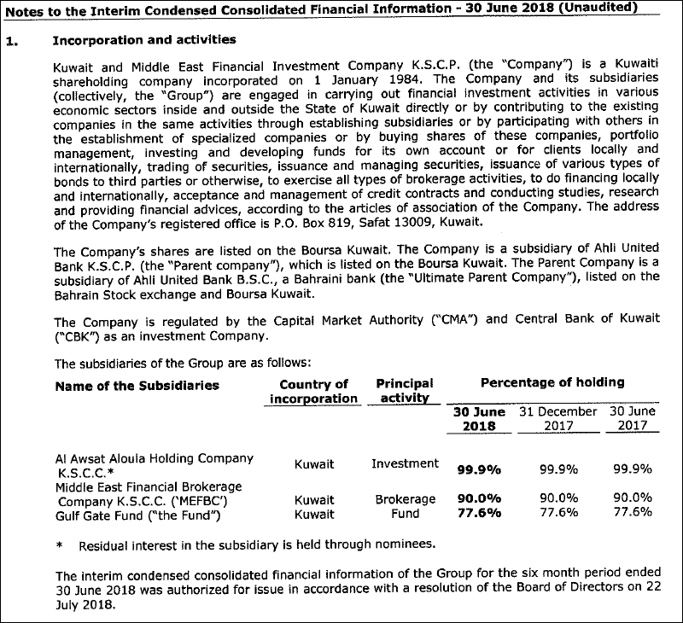
To add this note, the text editor can be opened by double clicking the text-block field for notes as shown below:
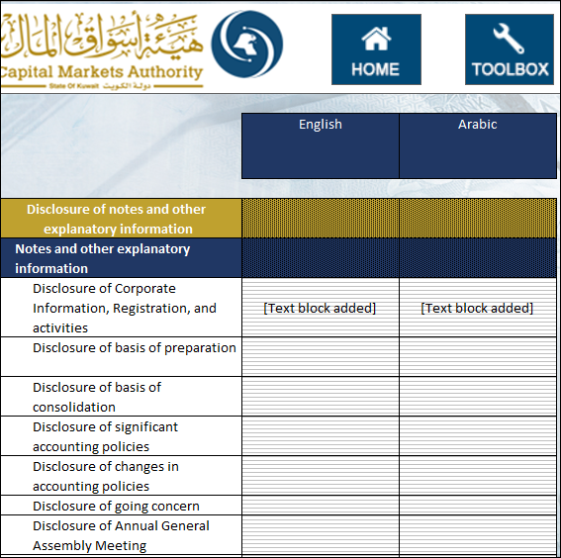

The user can add the disclosure for notes to financial statements and it will be included as a text block in the XBRL output of the CMA iFile. The user can enter the notes in both English and Arabic for the same period. Following is the example of text editor with a note added:
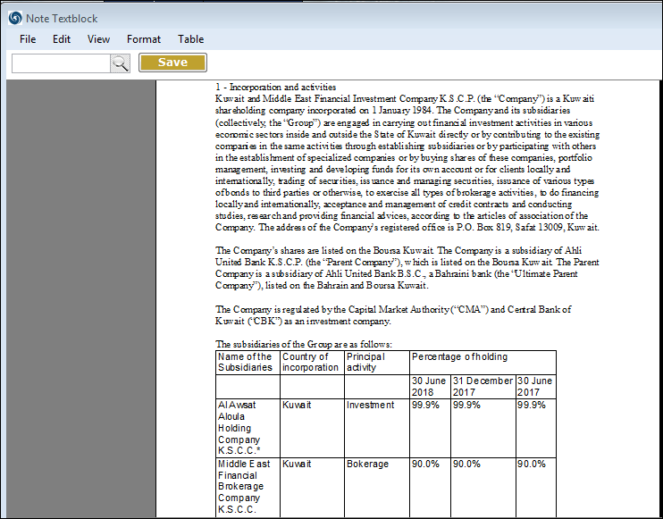
Kindly note that the text blocks for notes to financial statements in Arabic are mandatory.

Fair Value through Profit and Loss Investments

The user can input information pertaining to the companies FVTPL investments, for the local and foreign, listed and unlisted investments. For each of the investments, the user will be required to input the following information:
- Investment Type
- Type of product
- Investment products list
- Name
- Region
- Country
- Number of shares
- Cost per share
- Total Cost
- Market value per share
- Total market value
- Date of last valuation of unquoted shares
- Realized Gains / (Losses)
- Unrealized Gains / (Losses)
- Underlying Currency
- Credit Rating (for debt instruments)
The information input in this template will have to match that inputted as part of the information inputted in the Balance Sheet and Income Statement.
- The sum of the ‘Total Market Value’ in the Fair Value Through Profits and Loss Investments template must equal the ‘Financial Assets at Fair Value through profit or loss’ in the Statement of financial position template.
- The sum of the ‘Realized Gains / (Losses)’ in the Fair Value Through Profits and Loss Investments template must equal the ‘Realized gains (losses) on sale of financial assets at fair value through profit and loss’ in the Income Statement, nature of expense template
- The sum of the ‘Unrealized Gains / (Losses)’ in the Fair Value Through Profits and Loss Investments template must equal the ‘Unrealized gains (losses) on sale of financial assets at fair value through profit and loss’ in Income Statement, nature of expense template

Financial Assets at Fair Value through Other Comprehensive Income

The user can input information pertaining to the companies FAFVOCI investments, for the local and foreign, listed and unlisted investments. For each of the investments, the user will be required to input the following information:
- Investment Type
- Type of product
- Investment products list
- Name
- Region
- Country
- Number of shares
- Cost per share
- Total Cost
- Market value per share
- Total Market Value
- Date of last valuation of unquoted shares
- Realized Gains / (Losses)
- Change in Fair Value during the period
- Impairment loss during the period
- Accumulated Impairment Balance
- Reserve of change in Fair value
- Underlying Currency
- Credit Rating (for debt instruments)
The information input in this template will have to match that inputted as part of the information inputted in the Balance Sheet and Income Statement.
- The sum of the ‘Total Market Value’ in the Financial Asset at Fair Value through Other Comprehensive Income template must equal the sum of ‘Financial asset at fair Value through other comprehensive income’ in the Statement of financial position template
- The sum of the ‘Realized Gains / (Losses)’ in the Financial Asset at Fair Value through Other Comprehensive Income template must equal the ‘Realized gains on sale of financial assets at fair value through other comprehensive income - Debt instruments’ in the Income Statement, Nature of expenses template and Transfer of gain / loss on disposal of financial assets at fair value through other comprehensive income - equity instruments in the Statement of changes in equity template.
- The sum of the ‘Change in Fair Value during the Period’ in the Financial Asset at Fair Value through Other Comprehensive Income template must equal the ‘Net fair value change on financial assets at fair value through other comprehensive income - equity instruments’ and ‘Gains (losses) on re-measuring Financial assets at fair value through other comprehensive income - Debt instruments’ in the Statement of comprehensive income - Net of tax statement template.

Financial Assets Carried at Amortized Cost

The user can input information pertaining to the companies FACAC investments, for the local and foreign, listed and unlisted investments. For each of the investments, the user will be required to input the following information:
- Investment Type
- Name
- Region
- Country
- Product Type
- Acquisition Date/Start Date
- Underlying Currency
- Carrying amount
- Amortized cost
- FX Translation Change
- Maturity
- Credit Rating
- Fair Value
The information input in this template will have to match that inputted as part of the information inputted in the Balance Sheet.
- The sum of the ‘Carrying amount’ in the Financial Assets Carried at Amortized Cost template must equal the ‘Financial assets carried at amortized cost’ in the Statement of financial position template.

Investments in Associates

The user can input information pertaining to the company’s Investment in associates, for the local and foreign investments. For each of the investments, the user will be required to input the following information:
- Name
- Region
- Country
- Listing Status
- Investment Type
- Underlying Currency
- Carrying amount (Ending)
- Carrying amount (Beginning)
- Percentage of ownership
- Dividend received
- Impairment expense / (reversal)
- Share of Results
- Share of Other Comprehensive Income
- FX Translation Change
- Other movement
- Acquisitions/ Disposals/ Redemption
- Fair value (for listed investment based on market price)
The information input in this template will have to match that inputted as part of the information inputted in the Balance Sheet.
- The sum of the ‘Carrying amount (Ending) in the Investment in associates template must equal the ‘Investment in associates’ in the Statement of financial position template.

Borrowed Funds

The user can input information pertaining to the company’s borrowed funds. The user will be required to input the following information:
- Name of Bank / Financial Institution
- Region
- Country
- Underlying Currency
- Loan Type
- Amount
- Interest Rate
- Status
- Collateral Amount
- Collateral Type
- Due Date
- Payment Frequency
- Are there covenants?
- Purpose
The information input in this template will have to match that inputted as part of the information inputted in the Balance Sheet.
- The sum of the ‘Amount’ in the Borrowed fund template must equal the ‘Borrowings’ in the Statement of financial position, order of liquidity template.

Asset Management Portfolio

The user has to input information pertaining to the portfolio and funds, for both institutional and non-institutional clients.
The user will have to input information on the number and amount of portfolio/funds for the following:
- Portfolios managed by the Company
- Portfolios managed by the Client
- Custodian portfolios
- Managed mutual funds

