**CMA’s XBRL Based Electronic Filing Platform**

**IFSAH**

**Case Study for Other sector firm**

Version 1.0



Contents

1. Creating a filing 3

2. Filing information 4

3. Statement of financial position 4

4. Income Statement 7

5. Statement of Comprehensive Income 9

6. Statement of Cash Flows, Indirect method 11

7. Statement of Changes in Equity 14

## Creating a filing

On opening the iFile Tool, the filer can click on the ‘Click here to Create Filing’ button.

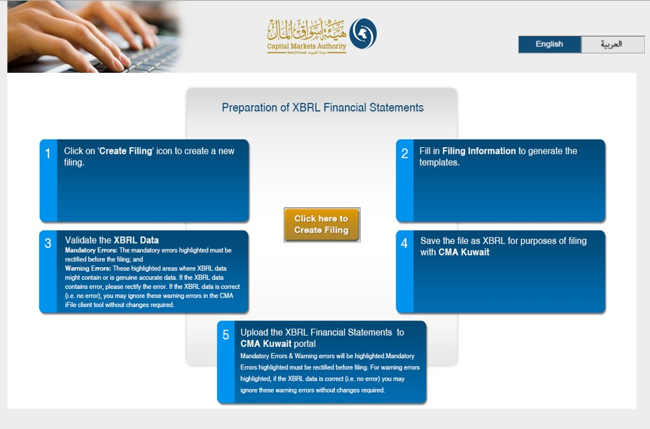

## Filing information

By clicking on the ‘Click here to Create Filing’ button, the user will be redirected to the CMA iFile pop-up, where he/she will be required to input information about the reporting entity.

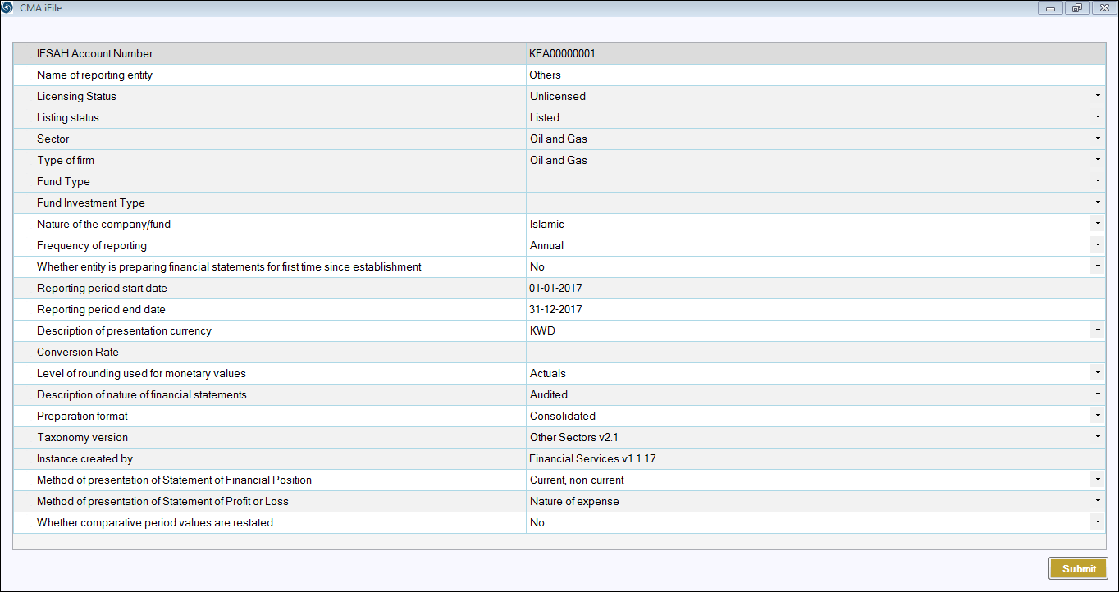

## Statement of financial position

Following is a snapshot of the company’s Statement of Final Position, from their annual report.

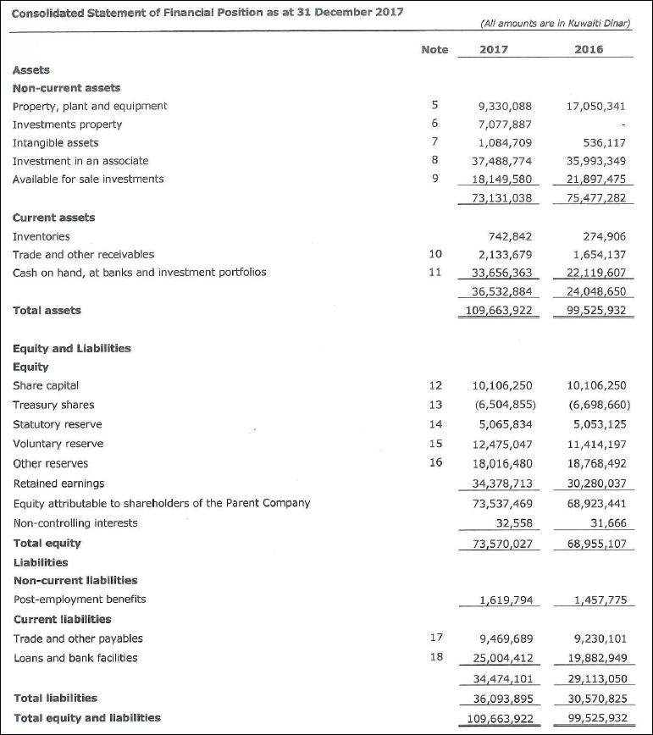

The company also reports a Treasury shares in the Statement of financial position. As the financial concept for ‘Treasury shares’ used in iFile has a debit balance, representing a negative impact on total equity (which has Credit balance). Hence, even though value of treasury shares is shown as negative in the report (as shown in the extract of report above), it is entered as positive in iFile. This is shown as follows:

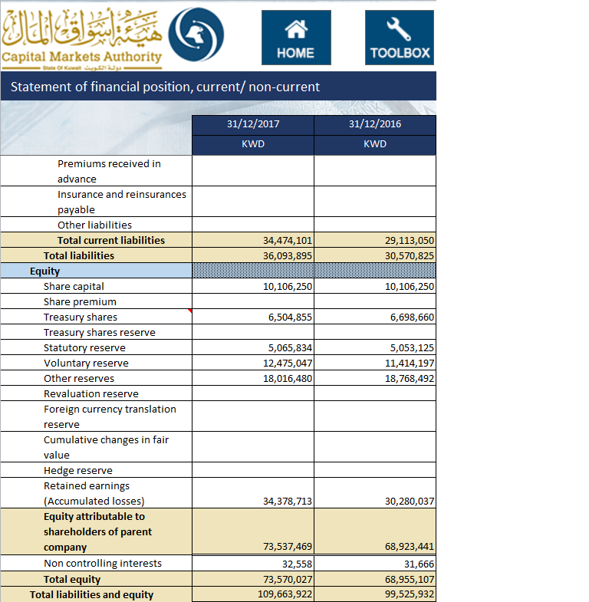

Following is the list of business concepts for which mandatory inputs are required. In the event that the company does not have any inputs, the user can input ‘0’, and the same will be displayed in the final filing document.

* Total assets
* Total equity
* Total liabilities
* Cash and cash equivalents
* Issued capital
* Retained earnings

Additionally, for the following concepts, when the user enters a positive value in the CMA iFile, that value will be deducted from the total, and vice-versa. For example, if the user enters positive value for ‘Treasury shares cost’, the value will be deducted from the total concept ‘Total equity’, and vice versa.

Following is a element that have a negative effect on the total in Statement of Financial Position:

Treasury shares

## Income Statement

Following is the Statement of Income from the Report:

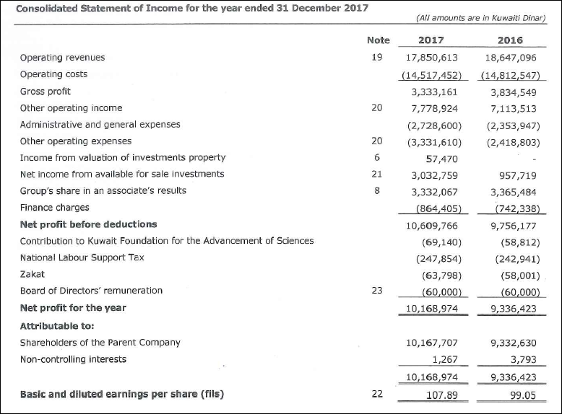

The details mapped in CMA iFile is as follows: (extract of it)

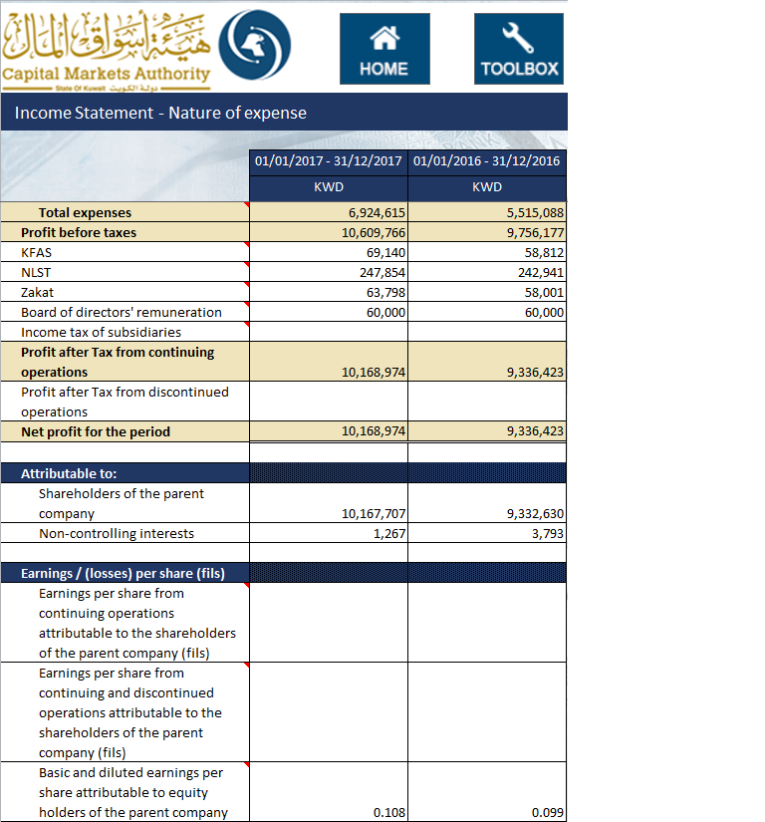

The profit (loss) from discontinued operations is shown after ‘PROFIT AFTER TAX FROM CONTINUING OPERATIONS’. However, as per the format of CMA iFile, profit after tax from continuing operations is shown as part of Revenue (as shown above).

*Kindly note that in the CMA iFile, the earnings per share are shown in Kuwaiti Dinar (KWD). As the company has reported earnings per share in fils, the same has been converted in KWD and entered in iFile as shown above.*

Following is the list of business concepts for which mandatory inputs are required. In the event that the company does not have any inputs, the user can input ‘0’, and the same will be displayed in the final filing document.

* Total revenue
* Total expenses
* Net profit (loss)

Following is the list of elements that have a negative effect on the total:

* Total expenses
* KFAS
* NLST
* Zakat
* Board of director’s remuneration
* Income tax of subsidiaries

## Statement of Comprehensive Income

Following is the Statement of Comprehensive Income from the Report:

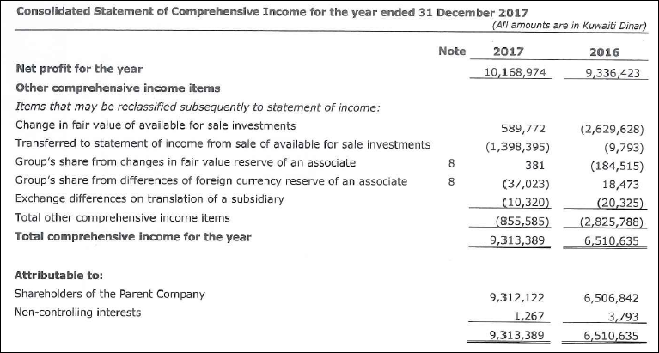

*Kindly note the following:*

* *The concept ‘Transferred to statement of income from sale of available for sale investments’, is the same as the following concept in CMA iFile – ‘Net transfer to consolidated income statement on disposal’.*
* *The concept in CMA iFile – ‘Net transfer to consolidated income statement on impairment’.*
* *Both these concepts have debit balance. As a result, these concepts will have negative impact on other comprehensive income, which has credit balance. Hence, the values entered in iFile are added taking into account the calculation relationship as per the balance type as shown below:*

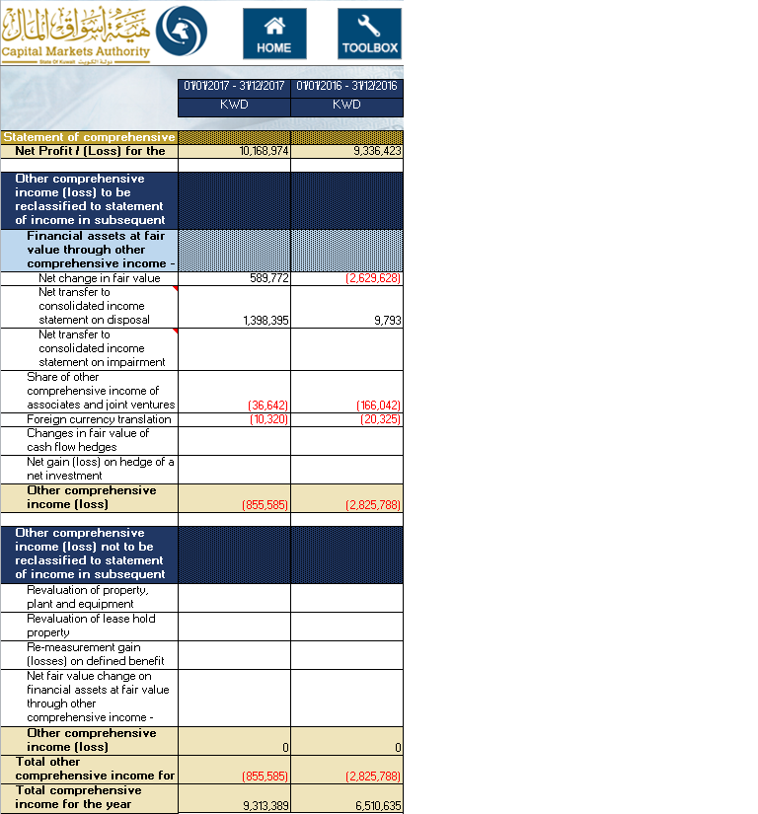

Following is the list of elements that have a negative effect on the total:

* Net transfer to consolidated income statement on disposal
* Net transfer to consolidated income statement on impairment

## Statement of Cash Flows, Indirect method

Following is the Statement of Cash Flows from the Report: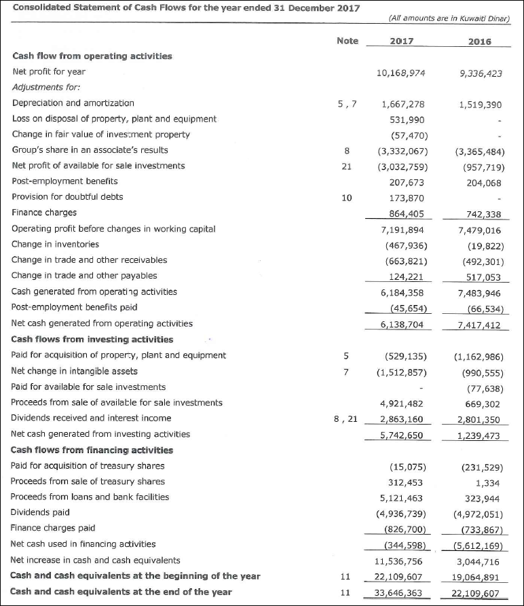

The details inputted in CMA iFile as follows: (an extract of it)

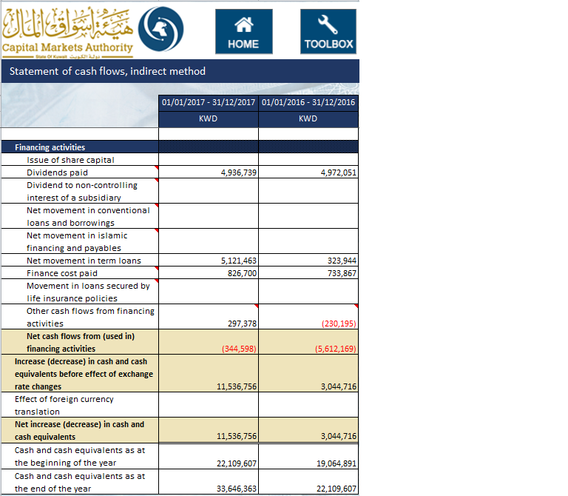

Note: Treasury shares purchased and Sold are mapped in CMA iFile in “Other Cash flows from financing activities” with a footnote assigned to it which looks as shown below:

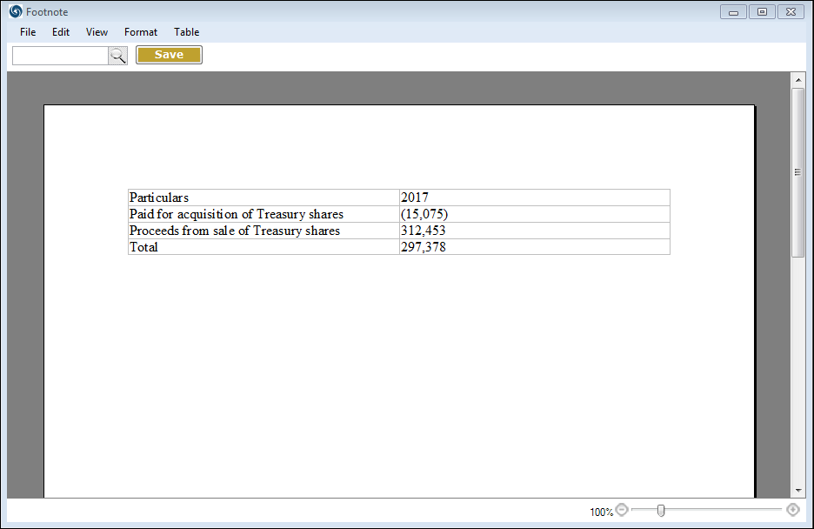

*Kindly note the following:*

List of elements that have a negative effect on the totals:

* Dividends income
* Net gains / (losses) from investments
* Share of results of associates and joint venture
* Gain from re-measurement of previously held interest in associates
* Gain from bargain purchase of subsidiary
* Gain/ (loss) on disposal of property, plant and equipment
* Gain/ (loss) on disposal of assets held for sale
* Interest income
* Monetary gain from hyperinflation
* Gain on settlement of borrowings and liabilities
* Loans secured by life insurance policies
* Liabilities arising from insurance contracts
* Premiums received in advance
* Insurance and reinsurances payable
* Insurance payable
* Other liabilities
* End of Service benefits paid
* Purchase of Financial assets at fair value through other comprehensive income
* Purchase of investments carried at fair value through profit or loss
* Acquisition of additional interest in an associate or joint venture
* Acquisition of a subsidiary, net of cash acquired
* Purchase of additional investment in a subsidiary
* Purchase of property, plant and equipment
* Proceeds from sale of property, plant and equipment
* Proceeds from disposal / redemption of Financial assets carried at amortized cost
* Investments in Financial assets carried at amortized cost
* Payment to acquire intangible assets
* Payment to acquire investment properties
* Dividends paid
* Dividend to non-controlling interest of a subsidiary
* Net movement in conventional loans and borrowings
* Net movement in Islamic financing and payables
* Finance cost paid
* Movement in loans secured by life insurance policies

## Statement of Changes in Equity

Following is the Statement of Changes in Equity from the Report:

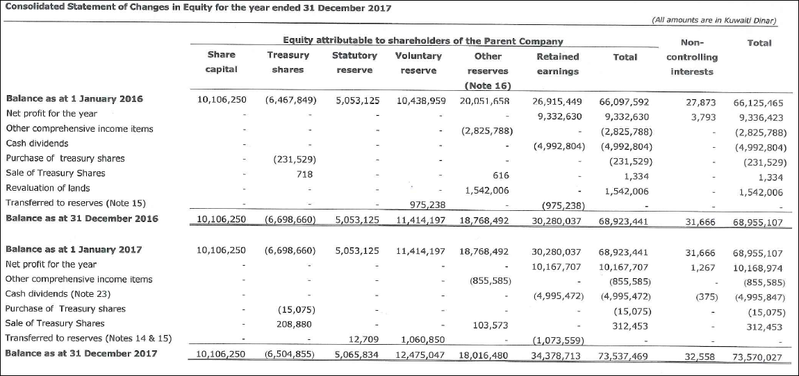

The details inputted in CMA iFile as follow:

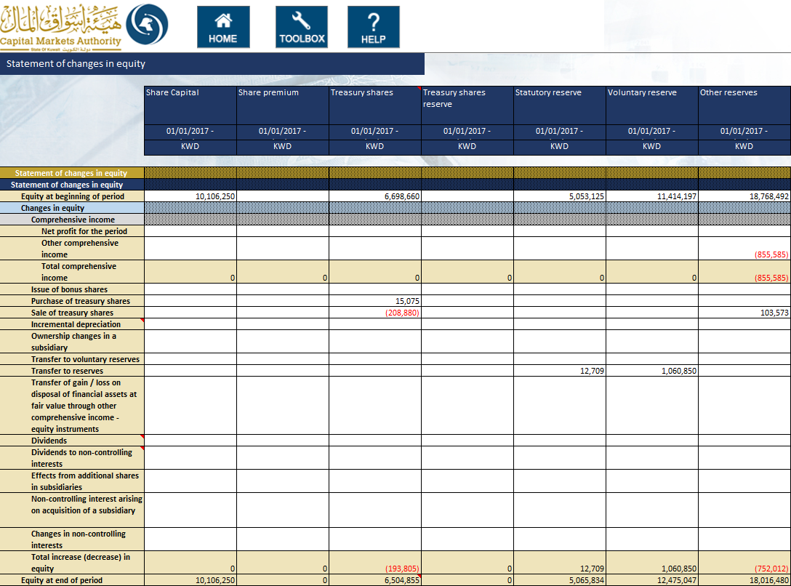

*Note: The concept ‘Treasury shares cost’ Column is subtracted from the Total equity calculation; therefore the amounts have been entered in positive as shown above.*

List of elements that have a negative effect on the totals:

* Incremental depreciation
* Dividends
* Dividends to non-controlling interests
* Total of Treasury Shares Column is deducted from the Total of Equity.

When the value for ‘Preparation format’ in Filing information selected is “Standalone” then Total equity attributable to the parent company and Non-Controlling interest’s column will be disabled.

The information input in this template will have to match that inputted as part of the information inputted in the Balance Sheet.

* The value reported for ‘Share capital’ in the Statement of changes in equity template must equal the value for ‘Share capital’ in the Statement of financial position template
* The value reported for ‘Share premium’ in the Statement of changes in equity template must equal the value for ‘Share premium’ in the Statement of financial position template
* The value reported for ‘Treasury shares’ in the Statement of changes in equity template must equal the value for ‘Treasury shares’ in the Statement of financial position template
* The value reported for ‘Treasury share reserve’ in the Statement of changes in equity template must equal the value for ‘Treasury share reserve’ the Statement of financial position template
* The value reported for ‘Statutory reserve’ in the Statement of changes in equity template must equal the value for ‘Statutory reserve’ in the Statement of financial position template
* The value reported for ‘Voluntary reserve’ in the Statement of changes in equity template must equal the value for ‘Voluntary reserve’ the Statement of financial position template
* The value reported for ‘Other reserves’ in the Statement of changes in equity template must equal the value for ‘Other reserves’ the Statement of financial position template
* The value reported for ‘Revaluation reserve’ in the Statement of changes in equity template must equal the value for ‘Revaluation reserve’ the Statement of financial position template
* The value reported for ‘Foreign currency translation reserve’ in the Statement of changes in equity template must equal the value for ‘Foreign currency translation reserve’ the Statement of financial position template
* The value reported for ‘Cumulative changes in fair value’ in the Statement of changes in equity template must equal the value for ‘Cumulative changes in fair value’ the Statement of financial position template
* The value reported for ‘Retained earnings (Accumulated losses)’ in the Statement of changes in equity template must equal the value for ‘Retained earnings (Accumulated losses)’ the Statement of financial position template
* The value reported for ‘Hedge reserve’ in the Statement of changes in equity template must equal the value for ‘Hedge reserve’ the Statement of financial position template
* The value reported for ‘Total equity attributable to the Parent Company’ in the Statement of changes in equity template must equal the value for ‘Total equity attributable to the Parent Company’ the Statement of financial position template (only in case of Consolidated)
* The value reported for ‘Non-controlling interests’ in the Statement of changes in equity template must equal the value for ‘Non-controlling interests’ the Statement of financial position template (only in case of Consolidated)