CMA’s XBRL Based Electronic Filing Platform

IFSAH

Instruction Manual for Company Users
Version 1.0

Contents
1. Accessing the IFSAH Portal 3
2. Registration 3
3. Log – In 4
4. Dashboard 4
5. Filing calendar 6
6. Upload filing 7
7. Following validation status of the filing 8
8. Pending filing 9
9. Viewing history of the filings 12
10. Inquiry module 14
11. Downloading the installer 16
12. Downloading the taxonomy template 17

Accessing the IFSAH Portal

The Company Users (CUs) can access the IFSAH portal through any browser, as long as they are connected to the internet. CUs can then login into the IFSAH portal through the following link
https://ifsah.cma.gov.kw/login/login.

Registration

The CU will be registered by Company Super User (CSU), after which an email with the username and a One Time Password (OTP) will be sent to the CU. The CU can login into the IFSAH portal with the username and the OTP. This portal can be accessed in either English or Arabic.
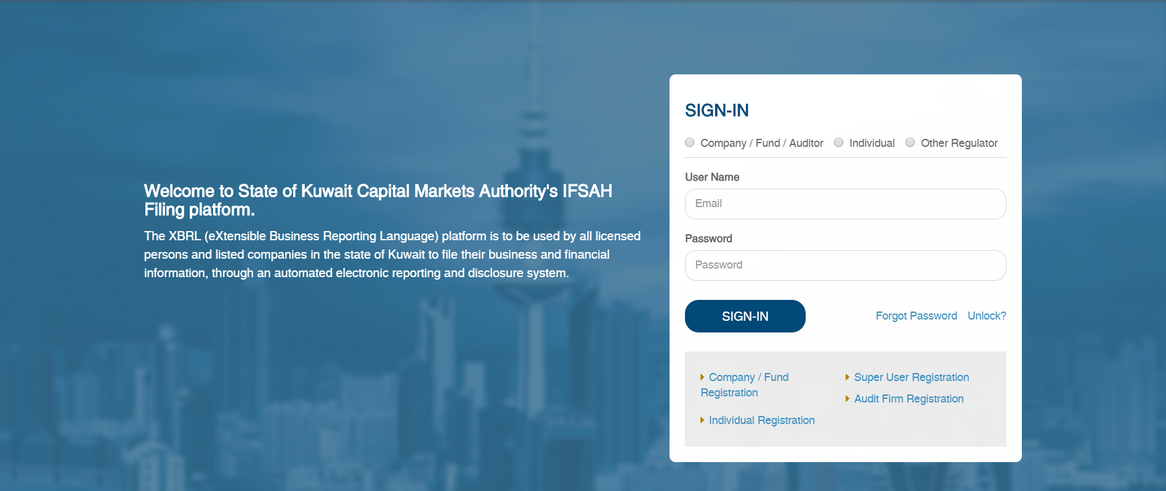

Log – In

Once the CU has successfully logged in with the OTP, the CU will be navigated to the “Change Password” page to set a new password.
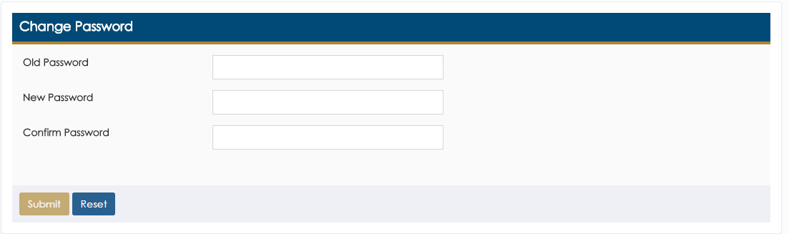
Upon setting the new password, the CU will be required to login in again with the new password.

Dashboard

On logging into the portal successfully, the CU will be navigated to the Dashboard.
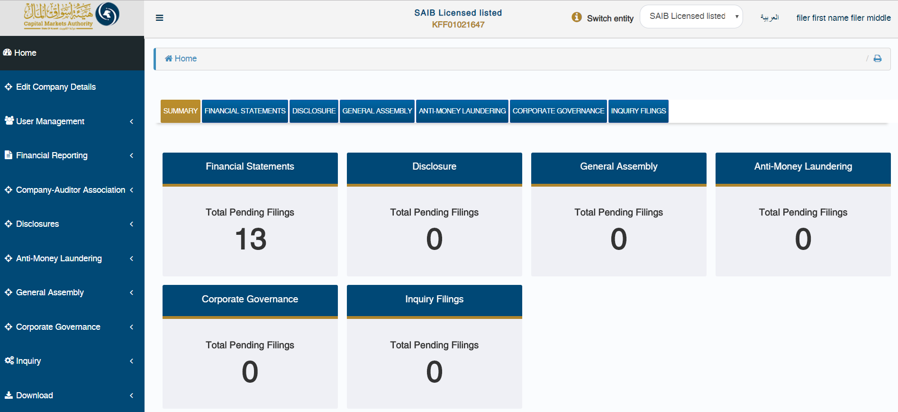

As can be seen on the dashboard, the CU can navigate between all the domains she/he has access to, including the module on reviewing the inquiry filings.

Filing calendar

The CU can view the filing extension period allowed for specific filing frequency & year by clicking on ‘Financial Statements’ widget on Dashboard or ‘Financial Statement – View Filing Calendar’ menu option.
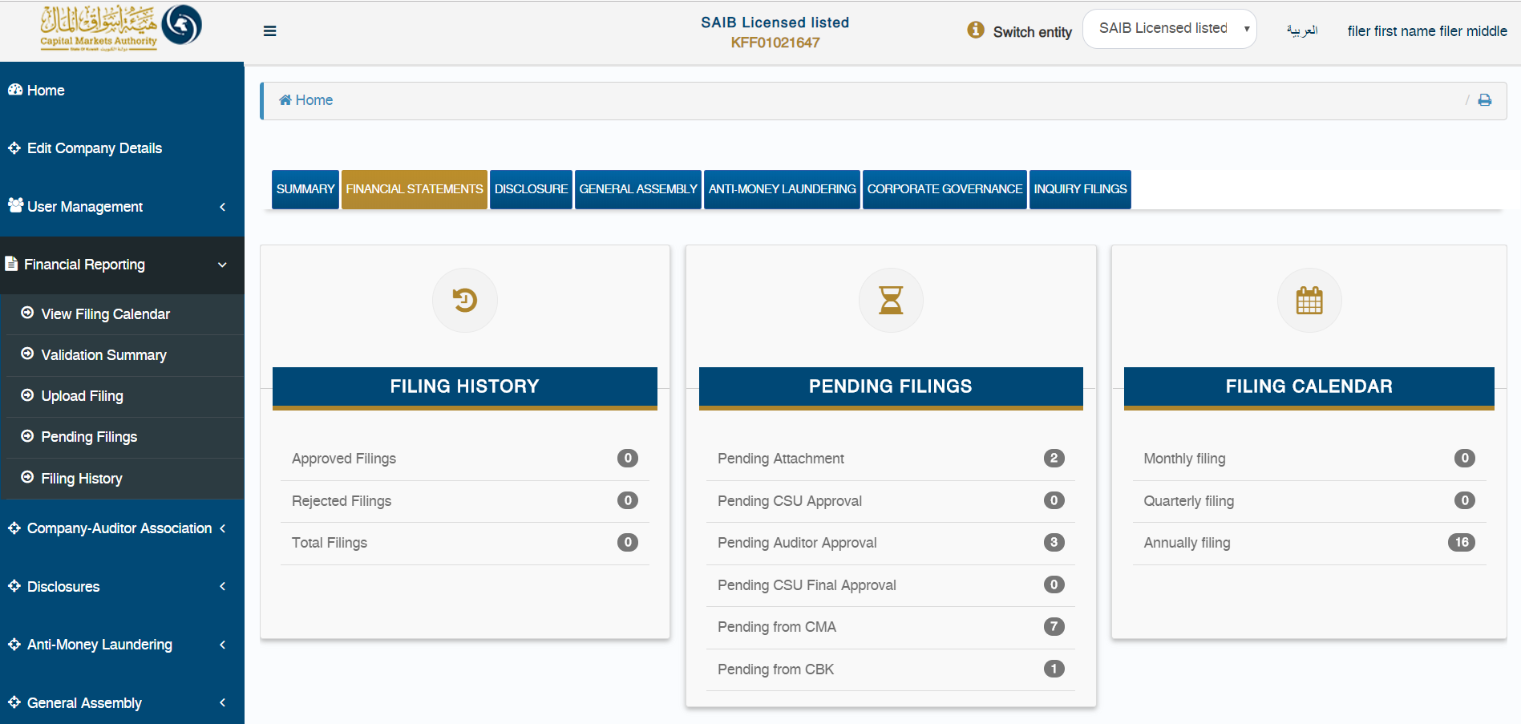

By clicking on either of the above options, the CU will be redirected to the ‘Filing Calendar Details’ page, where he/she can select the following:
- Filing frequency
- Sector
- Type of Firm
- Financial Year Format
- Year
for which the CU needs to view the filing period allowed by CMA, in order to upload filing within time. In the event that the CSU/CU uploads a filing after the stated period, the filing will be delayed.
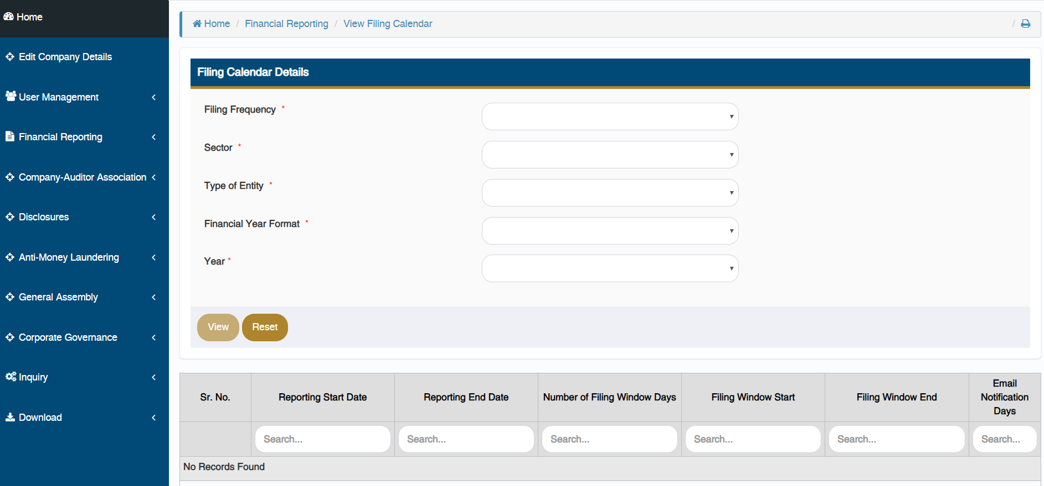

Upload filing

The CU can upload the XBRL instance file created from iFile tool on the portal through the ‘Upload XBRL Filing’ page. The CU can navigate to this page from Dashboard by clicking on ‘Submit Filing’ button available at the bottom of the page or using ‘Financial Statements – Upload Filing’ menu option.
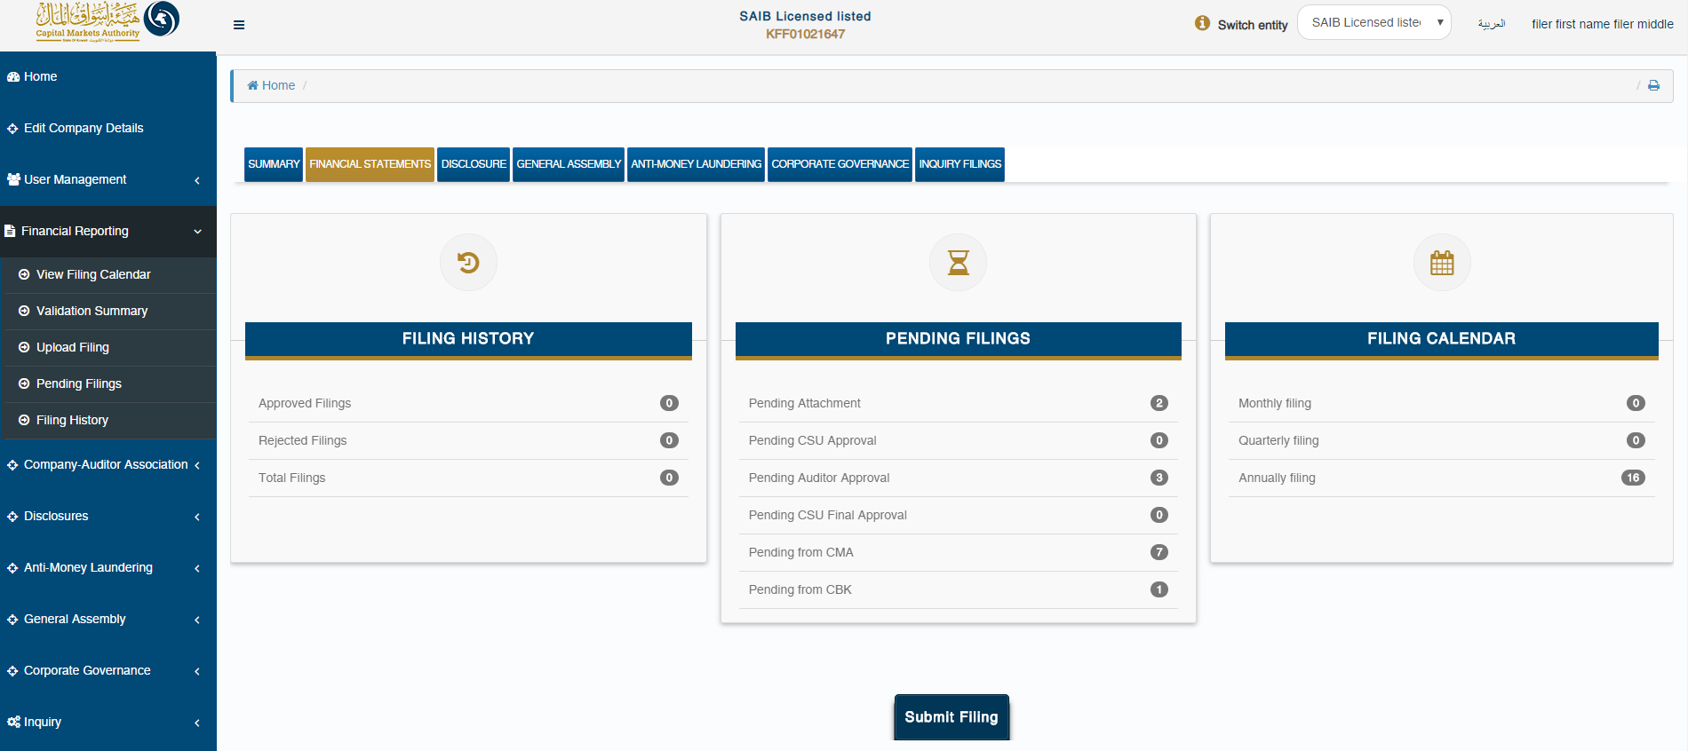
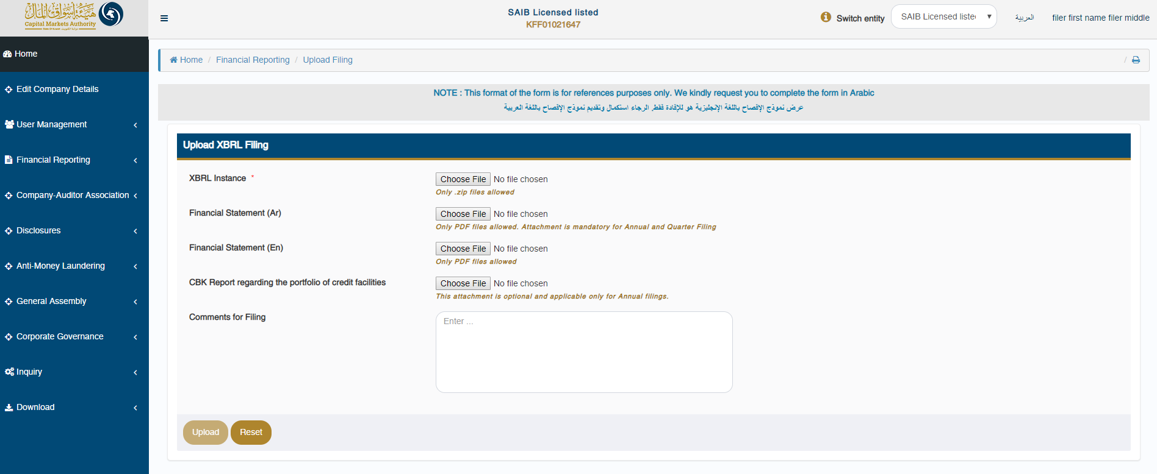

Following validation status of the filing

Once the XBRL instance file is successfully uploaded on the server, the CU will be navigated to the ‘Validation Summary’ page, for further validations.

The CU can check the validation status for that filing on this page. Based on the validation result, the CU can do either of the following:
- Navigate to ‘Pending Filing’ page if validation is successful or;
- Navigate to ‘Validation Error’ page in case the validation fails by clicking on “View Errors” link available.
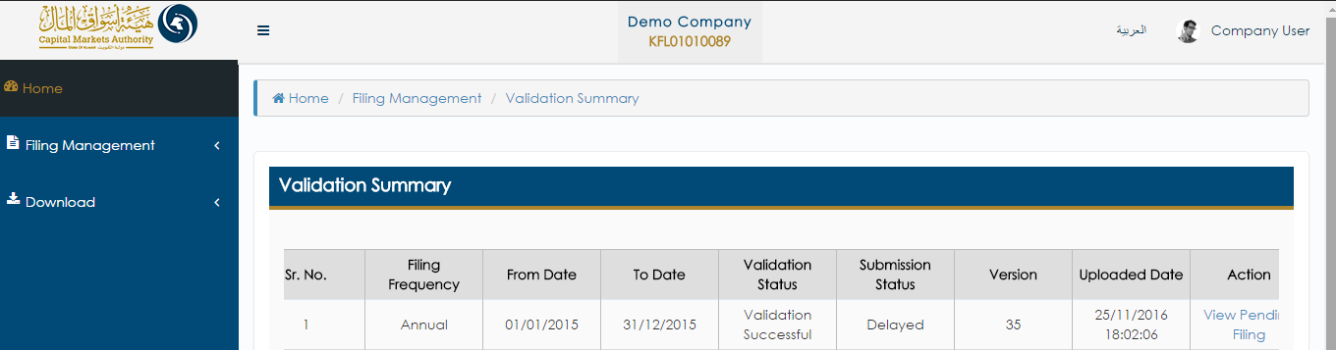

Pending filing

The CU can view filings pending his/her approval from by clicking on the ‘(Domain name) – Pending Filings’ menu option, or by selecting either of the tabs on the Dashboard.
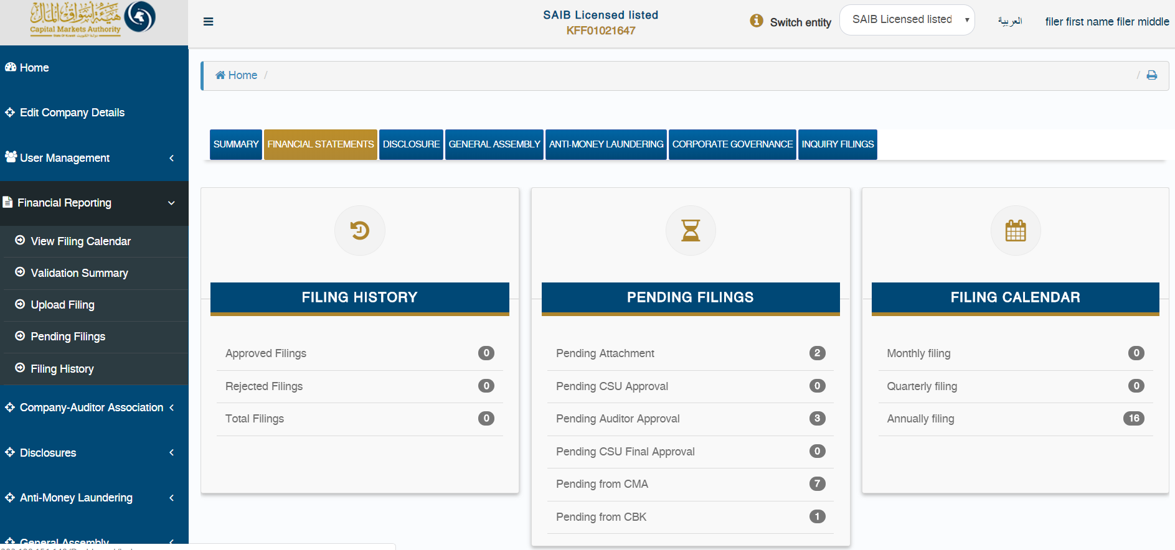
On the ‘Pending Filings’ page, the CU can view the ‘Filing Status’ & ‘Submission Status’ for any of the filings uploaded for their company. Here, the CU can also filter records based on various filters.
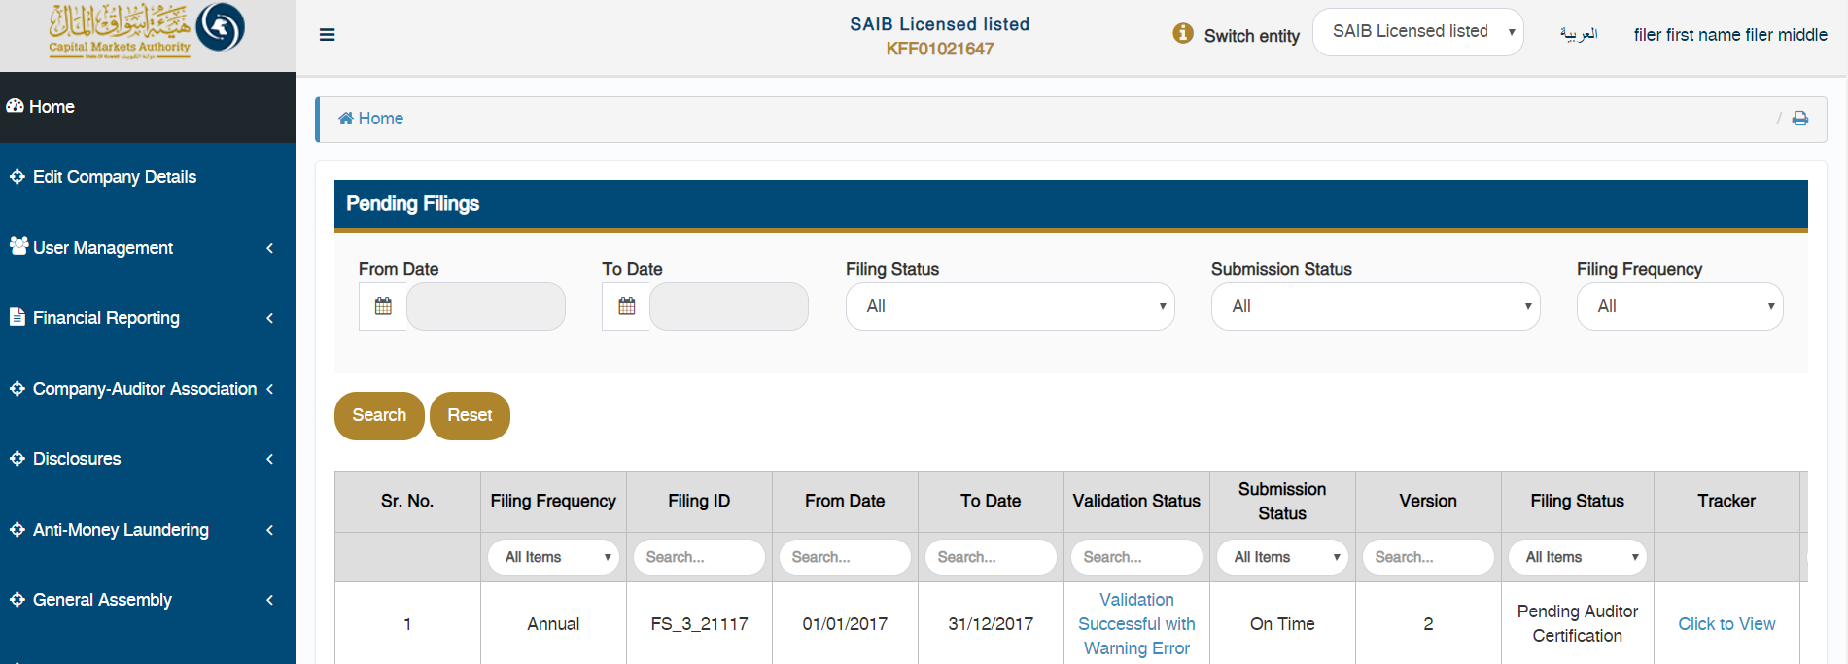
The CU can view the complete flow of any specific filing by clicking on the ‘Click to View’ link available under ‘View Comments’ column.

The CU can also hover with the mouse on the number displayed in the tracker, to view who uploaded the filing & when it was uploaded. The CU can view the comments for each filing status by clicking on ‘?’ icon displayed under each number in the tracker.
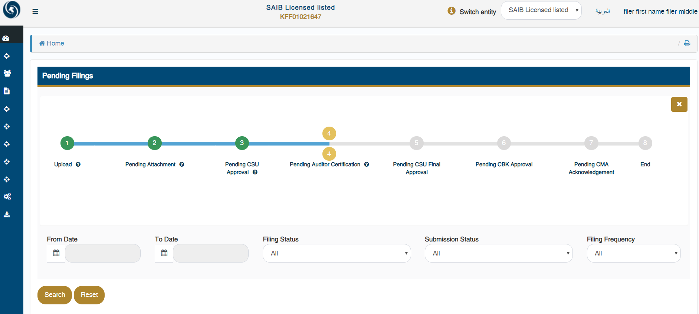
Lastly, the CU can view/approve/reject the data in the uploaded instance document by clicking on ‘View’ or ‘Approve/Reject’ link available under ‘Action’ column on ‘Pending Filings’ page.
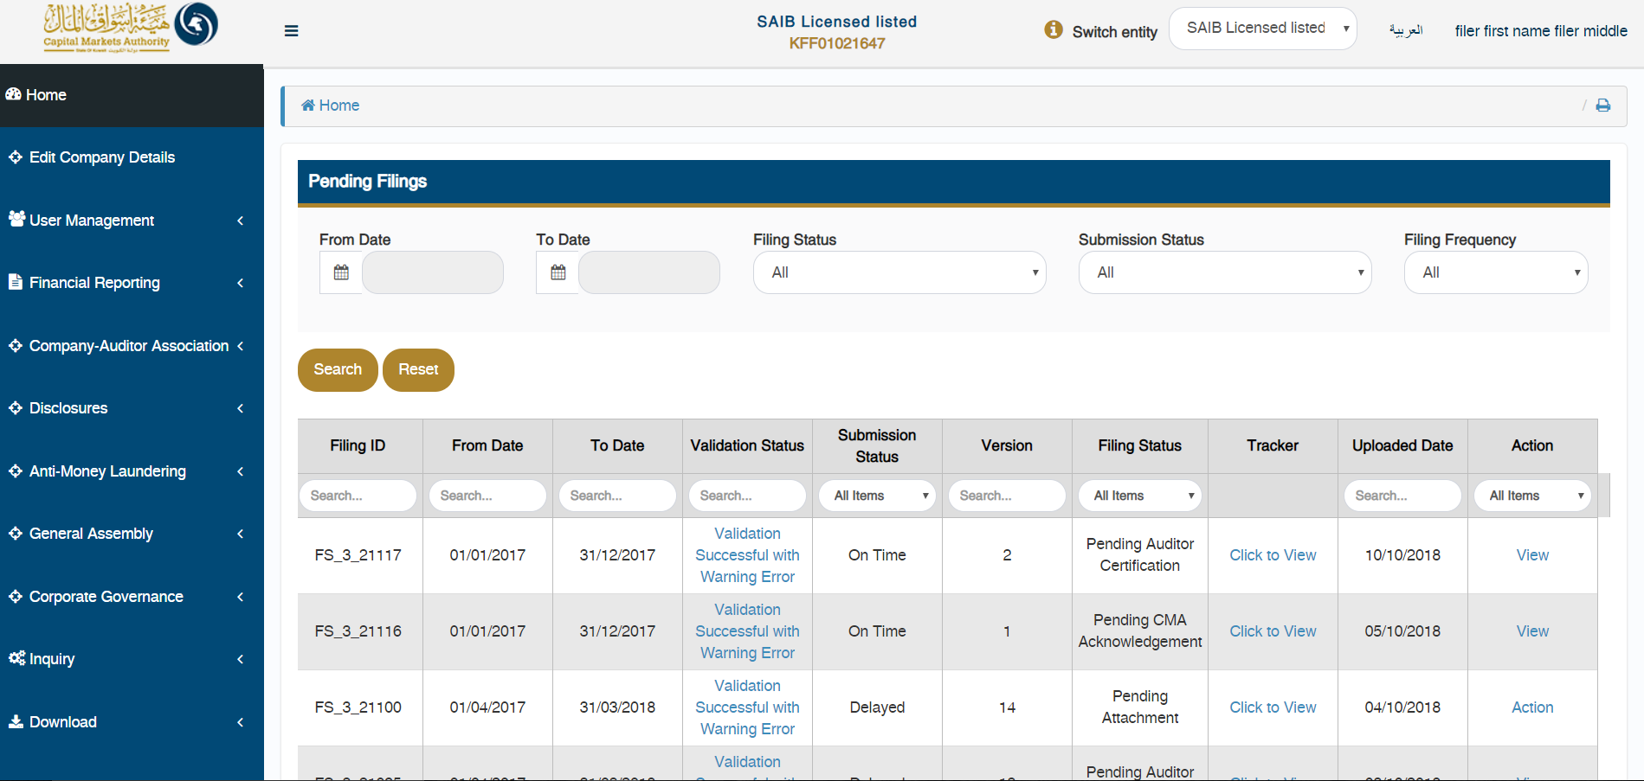

On doing so, the CU will be able to view all the details of the company, and the filing.
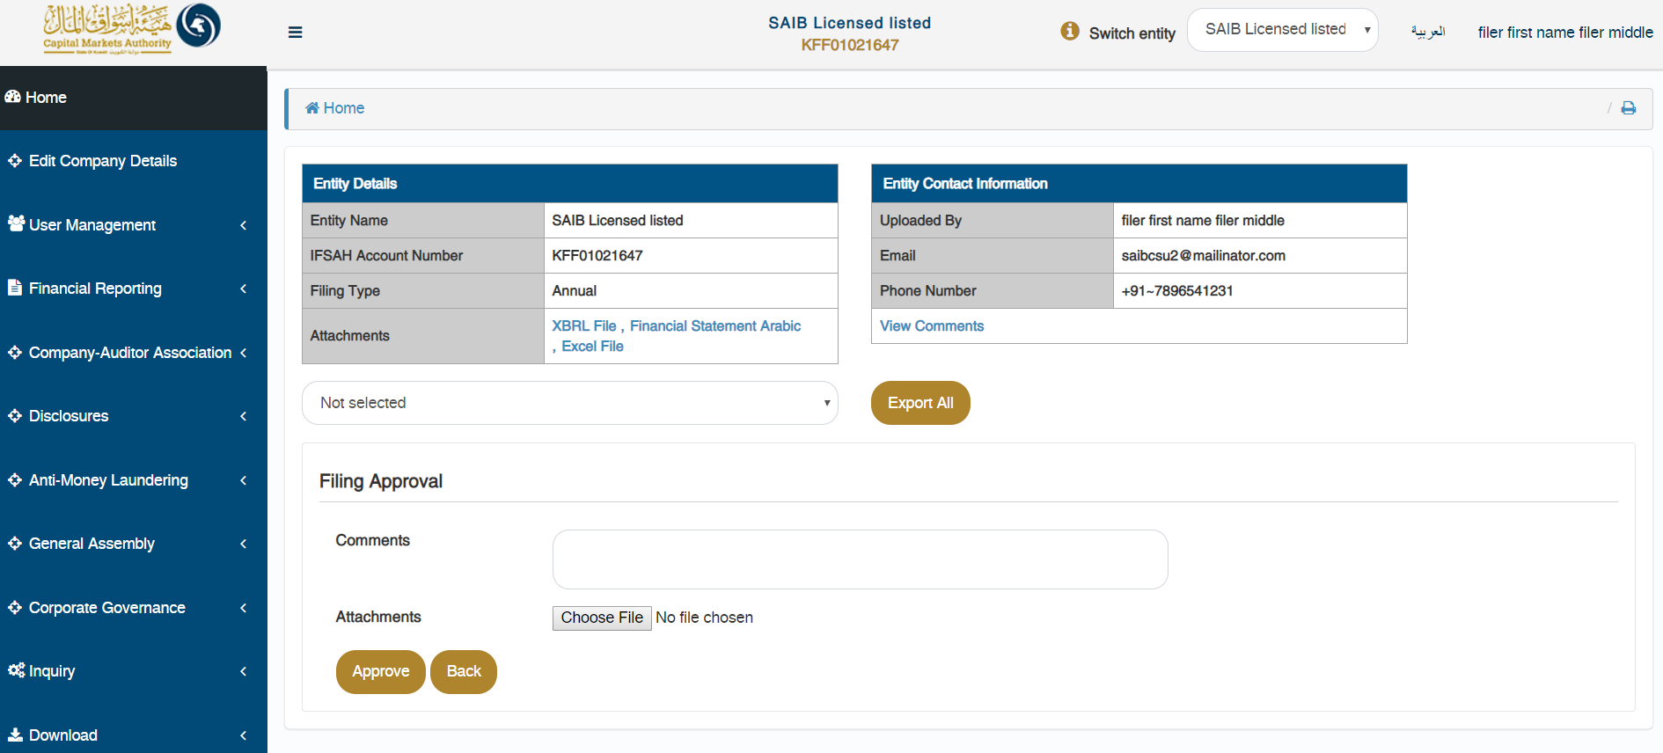

Viewing history of the filings

The CU can view the history of all the filings for their company, which have been approved or rejected by clicking on the ‘(Domain name) – Pending Filings’ menu option, or by selecting either of the tabs on the Dashboard.
By clicking on either of the options listed above, the CU will be able to view the filing history of all submissions.
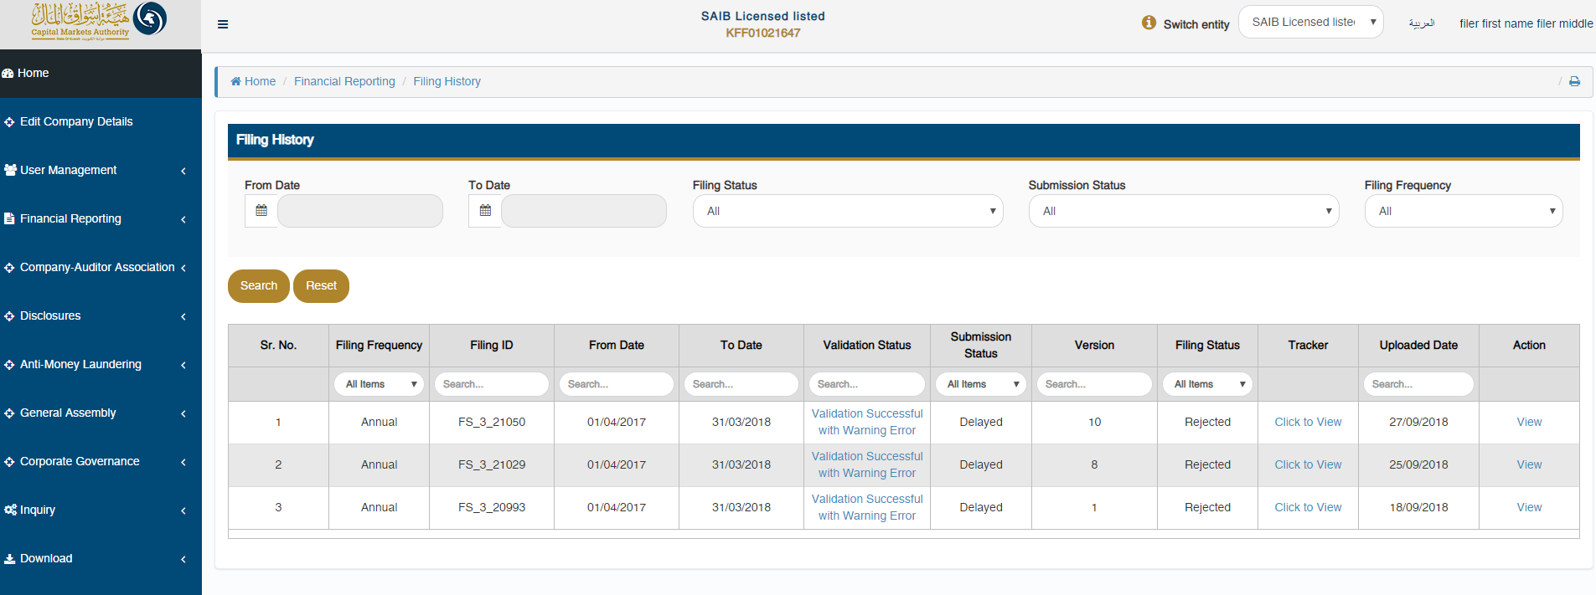

Inquiry module

The CU can submit inquiries to the CMA via the inquiry module. This ca be accessed by clicking on ‘Inquiry’ in the menu option. The status of closed inquiries and pending inquiries can be viewed by clicking on the ‘Inquiry filings’ tab on the dashboard.
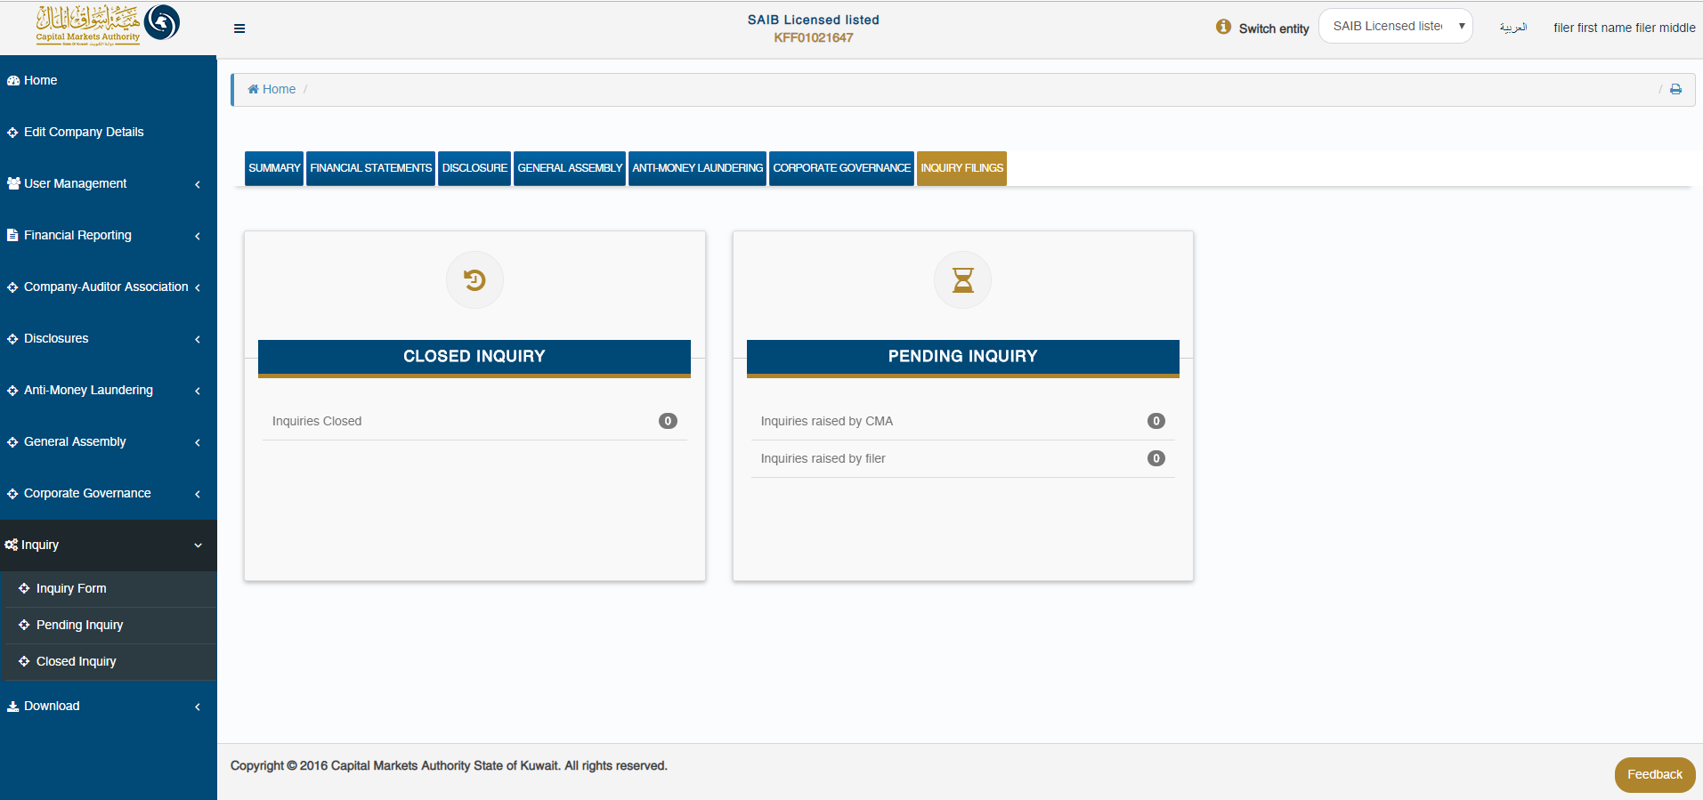
The CU can access the inquiry form by selecting the ‘Inquiry form’ dropdown under the ‘Inquiry’ option in the menu. Here, the CU has to select the domain and form name for which the inquiry is being submitted, whilst entering the inquiry in the comment section. The CU has the option to enter the Filing ID and attachment is relevant and required.
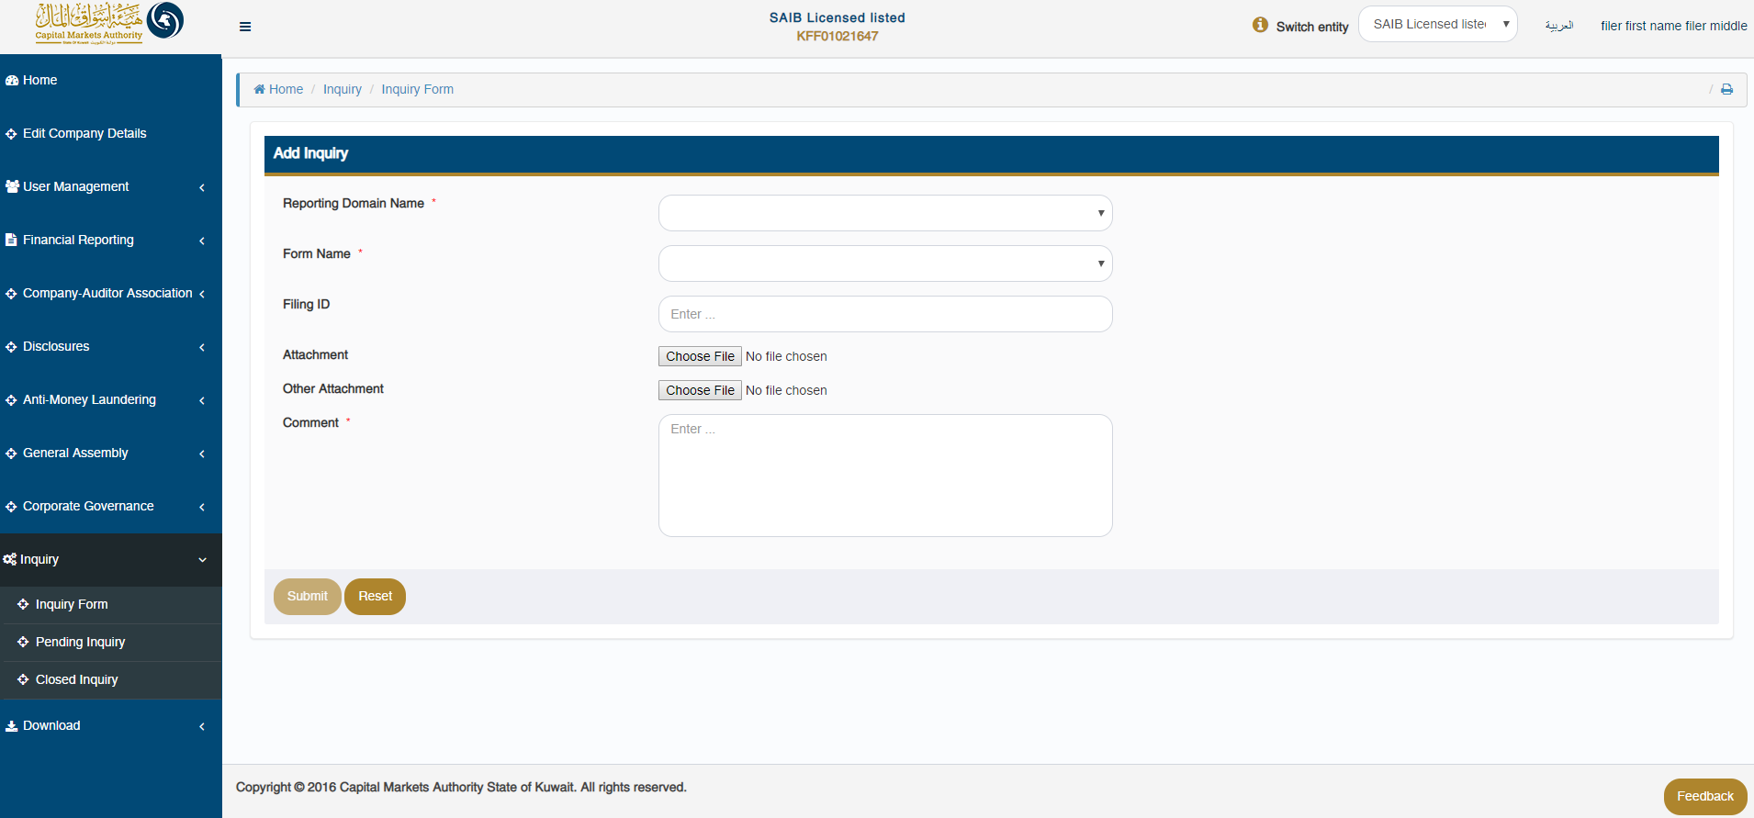
The CU can review all received/submitted inquiries in a tabular format, while filtering which filing to view based on the following criteria:
- Query Id
- Filing Id
- From Date
- To Date
- Filing Status
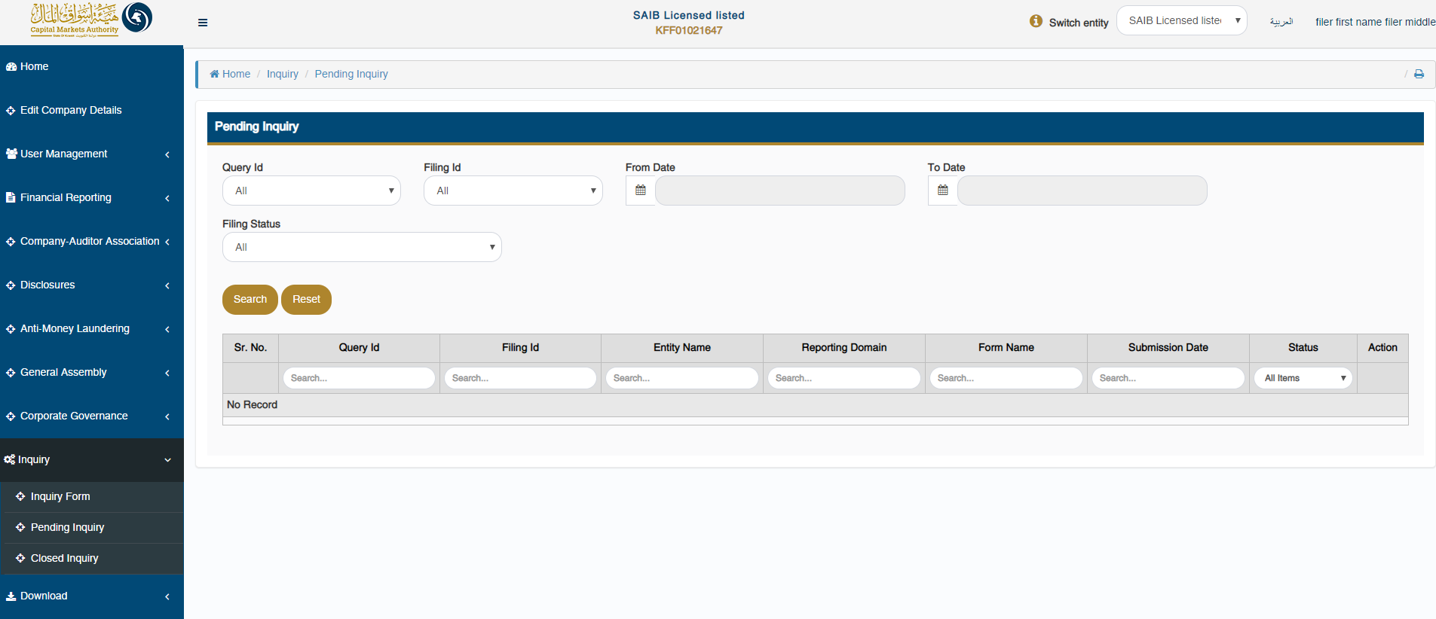

The CU can review all closed inquiries in a tabular format, while filtering which filing to view based on the following criteria:
- Query Id
- Filing Id
- From Date
- To Date
- Filing Status

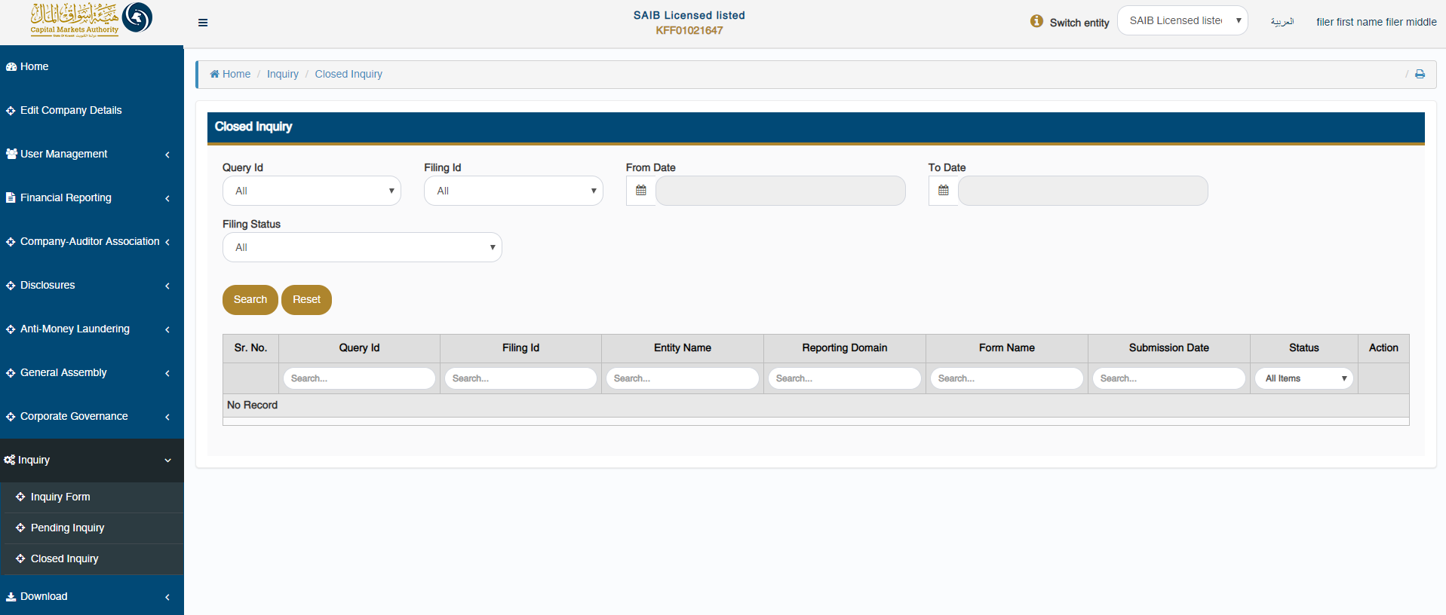

Downloading the installer

The CU can download the latest version of the iFile installer by clicking on the ‘Download – Download Installer’ menu option.
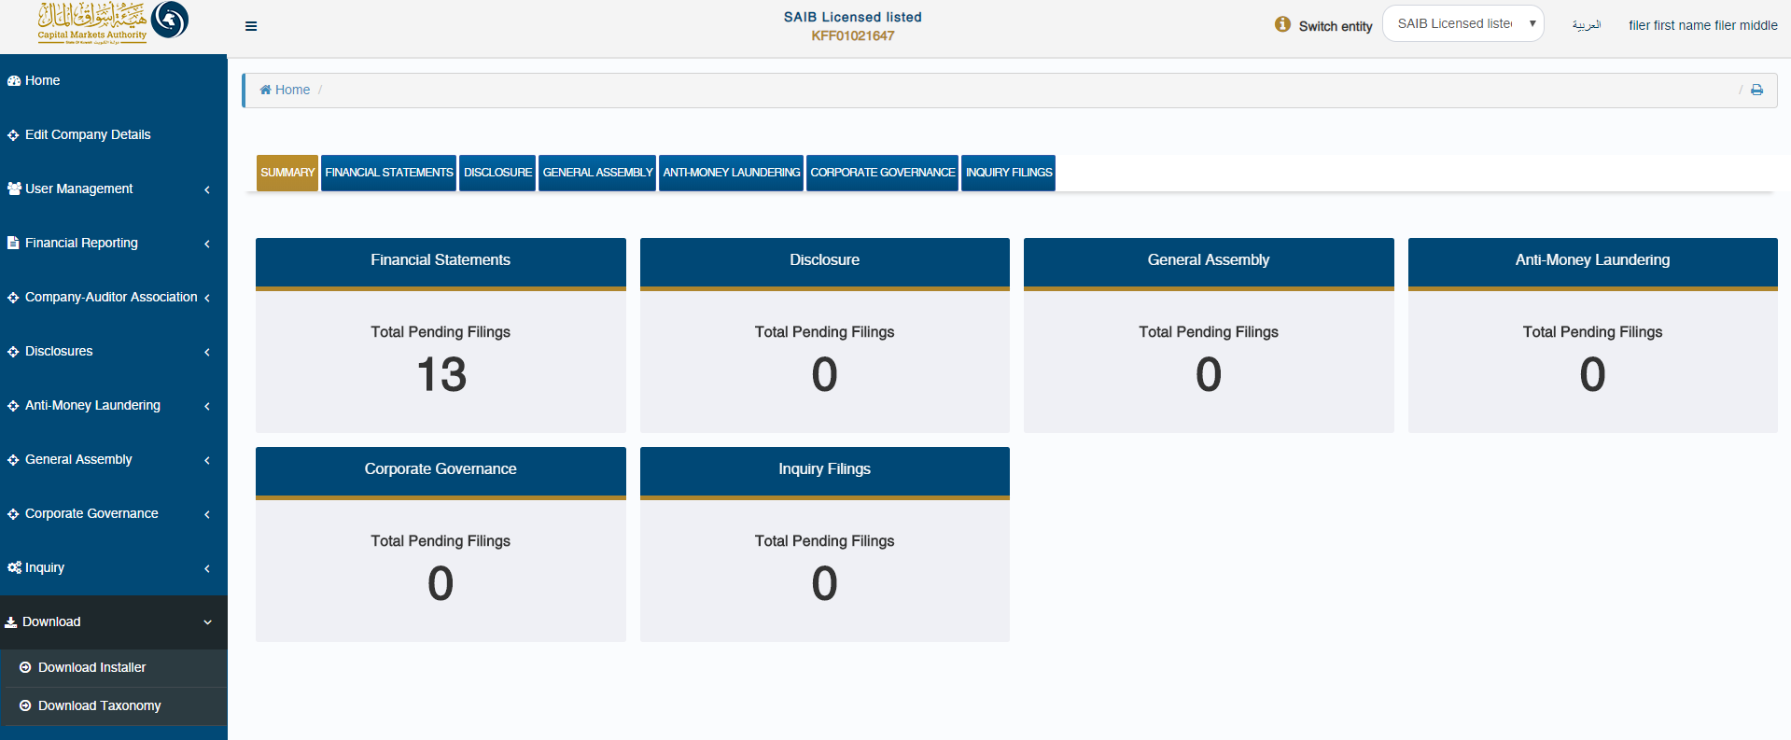
Here, the CU will have to input the relevant sector by selecting from the drop down field.
Based on their machine’s OS version, the appropriate installer file can be downloaded.
- In order to check the OS version of the machine, the CU can click on ‘Steps to identify Operating System (OS) Version’
- In order to view the prerequisites required to install the iFile installer, the CU can click on ‘Pre-requisite for installing the iFile tool’

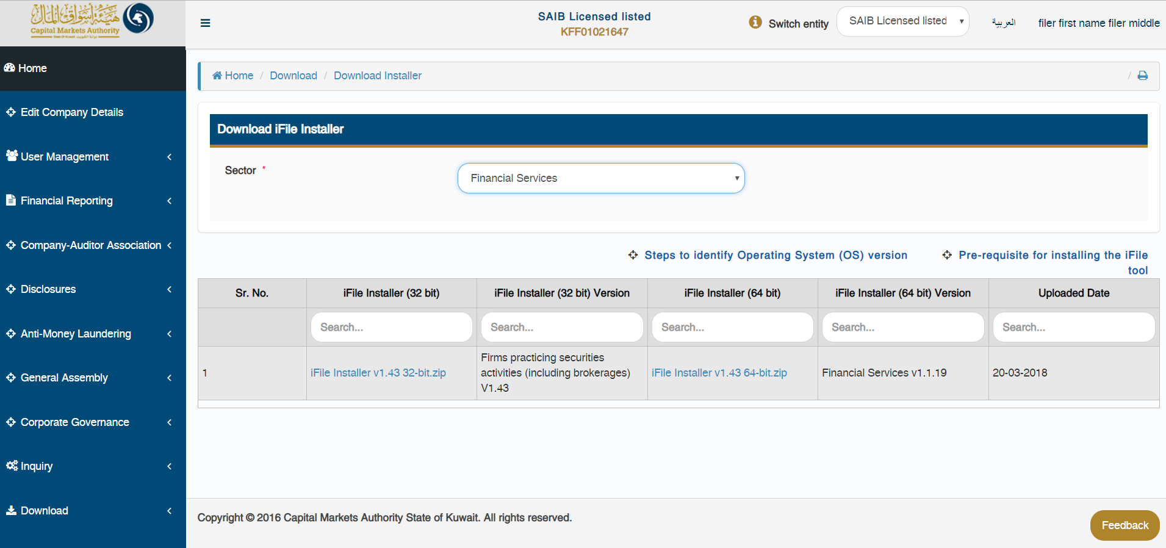

Downloading the taxonomy template

In order to download the relevant taxonomy templates, the CU can click on ‘Download – Download Taxonomy’ menu option.
Here, the CU can select the ‘Sector’ & the ‘Type of Firm’ for which taxonomy file needs to be downloaded.
